Drawing and Painting 2

Lesson 1: Zentangle Self-Portraits

Learning Objectives:

- I can draw my face in three-quarter, profile, upturned, and downturned views.
- I can identify the difference between a highlight, mid-tone, and core shadow.
- I can make three thumbnail sketches of my self-portrait with different angles, hand gestures, and facial expressions.
- I can make a final self-portrait using zentangle patterns.
- I can assess the strengths and areas of improvements of three other portraits my classmates made.

Materials | Technical/Conceptual Skills | Key Terms
- Pencil  - Sketchbook paper  - 9”x12” sulfite paper  - Ink pens | - Portrait drawing  - Pen and ink drawing  - Zentangle drawing | Zentangle: a type of repetitive, detailed pattern drawing commonly used in adult coloring books to reduce stress.  Portrait: a drawing, painting, or photograph of a person from the head to the shoulders. Hands are sometimes included.

Requirements for Project

Step 1: Pick a partner to help you take pictures on your phone of your face posing in a three-quarter, profile, or upturned/downturned pose. You must also evoke an emotion in each of your photos, such as anger, surprise, sadness, boredom, joy, etc. Don’t forget to play with hand and arm gestures. We will take the photos either outside or with studio lighting.

Step 2: Draw three thumbnail sketches with all of these poses, emotions, and hand gestures. Pick your favorite drawing of the three.

Step 3: For the self-portrait pose you pick, lightly sketch out where the highlights, gray shadows, and darkest core shadows of your face are. Think about it as if you are making a Shepard Fairey poster.
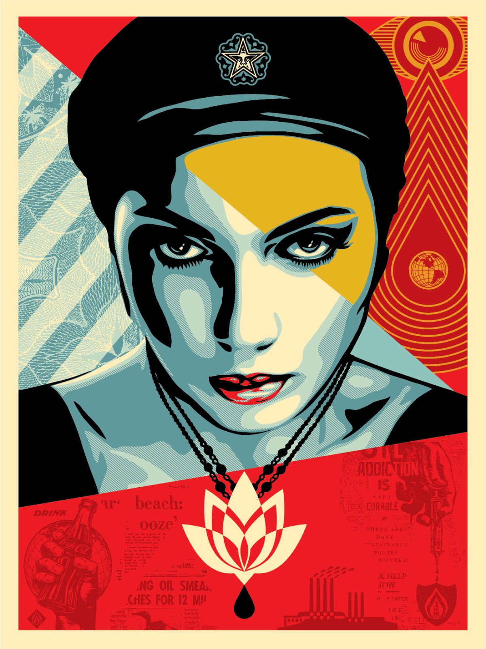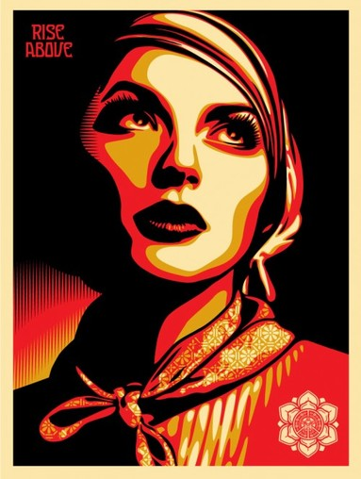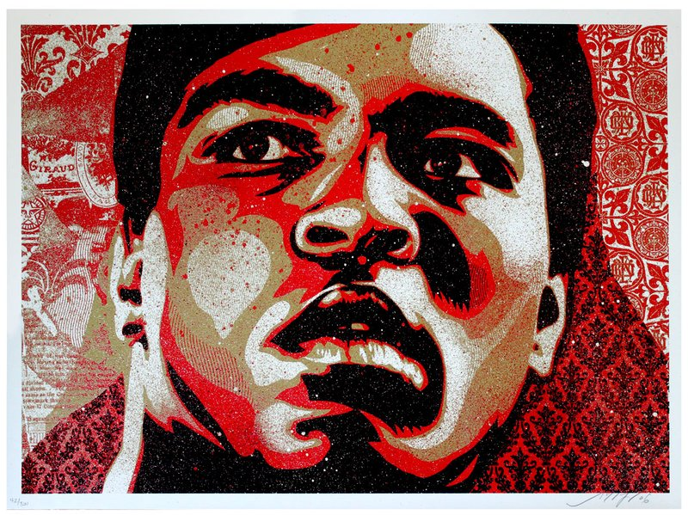
Step 4: Begin sketching out all of your zentangle patterns in your portrait. Be aware of how light or dark (AKA close together or spread out) your patterns are, as it will affect your values.

Step 5: Begin inking your project.
Shading Option 1: | Shading Option 2:
Separating each value and patterns with hard lines. | Letting the values and patterns blend into each other.

Grade Breakdown (100 pts.):

Portrait Practice Drawings and Thumbnails

Final Drawing

Critique Worksheet

Time Management and Effort

Timeline:
 | Day 1 | Day 2 | Day 3 | Day 4 | Day 5
Week 1 | Class discussion on the cultural and social meaning of portraits, as well as the style of portraits that are used by different artists.  Introduce the project. Review how to draw front on portrait. Begin demonstration on three-quarter view portrait. | Demonstration on profile and upturned/downturned angles. | Demonstration on drawing hands. | Take photos of portrait angles. Begin thumbnail sketches.  Goal: Have printed paper copies of your photos for tomorrow. If you have problems accessing a printer, please let Ms. N. know. | Finish thumbnail sketches.  For your favorite photo, outline all of the shapes on your portrait that are the highlights, mid-tones, and core shadows.  Begin drawing your final portrait onto the 16”x20” paper.  Goal: finish all thumbnail sketches and pick one for final portrait.
Week 2 | Work Day.  Goal: all basic shapes of the head should be finished. Details are beginning to form. | Work Day. | Work Day.  Goal: Completely finish drawing the face and outlining highlight, mid-tones, and core shadows. | Practice zentangle drawings on zentangle worksheet.  Goal: finish the worksheet. Know what patterns you plan to use for your mid-tones and core shadows. | Work Day. Begin drawing zentangle patterns on the skin, clothes, and hair with pencil.
Week 3 | Work Day.  Goal: half of zentangle patterns are drawn out. | Work Day.  Goal: all of zentangle patterns are finished. | Work Day. Begin inking drawing. | Work Day. | Work Day.  Goal: At least a third of the drawing is finished.
Week 4 | Work Day. | Work Day.  Goal: At last two-thirds or three-quarters of the drawing is finished. | Work Day. | Work Day.  Goal: All of the drawing is finished. | Critique Day.  Fill out the critique worksheet.  Feedback on the lesson and Ms. N’s instruction.

