Lesson Plan Title: Notan Animal Portrait Painting Length:

Note: Before you plan and write art experiences; pre-assess your students based on the proposed concepts, enduring understandings, and objectives of the unit/lesson(s). You may also gather this information from (previous) teachers, by reviewing already completed art work, consulting curriculum materials, etc., to get a better understanding of what content students already know and what they will need to know to be successful.

Pre-Assessment:
This will need to be done prior to teaching your lesson. Outline the method you will use to determine the skill/knowledge level of your students based on the concepts/enduring understandings/objectives of the lesson. (Hint: turn these into questions.) Be specific in describing what you would recognize as proficient skill/knowledge.
- Assess on all new vocabulary terms related to color, as well as notan art and bilateral symmetry

Performance:
What will students accomplish as a result of this lesson? This can be presented to students in the form of a story. In this narrative the students take on a role and create a learning product about a specific topic for a certain audience. (RAFT – Role / Audience / Format / Topic)
N/A

Concepts:
List the big ideas students will be introduced to in the lesson. These ideas are universal, timeless and transferrable. Examples of concepts used in art might include: Composition, Patterns, Technique, Rhythm, Paradox, Influence, Style, Force, Culture, Space/Time/Energy, Line, Law/Rules, Value, Expressions, Emotions, Tradition, Symbol, Movement, Shape, Improvisation, and Observation Look for concepts in the standards, content specific curriculum, etc.
Color, Symmetry, Contrast

Enduring Understanding (s):
Enduring Understandings show a relationship between two or more concepts; connected with an active verb. The best enduring understandings not only link two or more concepts; but demonstrate why this relationship is important. Like concepts, they are timeless, transferrable and universal.
Artists balance color and contrast to create symmetry in their work.

Standards: (All lessons should address all standards.)
1. Observe and Learn to Comprehend
2. Envision and Critique to Reflect
3. Invent and Discover to Create
4. Relate and Connect to Transfer

Objectives/Outcomes/Learning Targets:
Objectives describe a learning experience with a condition → behavior (measurable) → criterion. Aligned to: Bloom’s – Standards – GLEs - Art learning and, when appropriate, Numeracy, Literacy and Technology. Should be written as: Objective. (Bloom’s: _____ - Standard: _____ - GLE: _____ -Art learning: _____ -Numeracy, Literacy, and/or Technology)
Objective 1: After learning about color theory and how to mix paints, students will be able to construct a color wheel using acrylic paint.
- Blooms: Create
- Standard: Relate and Connect to Transfer
- GLE: Communication through advanced visual methods is a necessary skill in everyday life
- Art Learning: Materials and Techniques
- Numeracy: paint proportions when mixing colors, creating a value progression in a linear form

Objective 2: After learning about notan art and how to make a notan-style animal portrait, students will be able to design three thumbnail sketches of different notan animals with three different color schemes.
- Blooms: Create
- Standard: Observe and Learn to Comprehend
- GLE: Visual art has inherent characteristics and expressive features
- Art Learning: History and Culture, Ideation
- Numeracy: bilateral symmetry, paint proportions when mixing colors

Objective 3: After selecting their favorite thumbnail sketch, students will be able to create their final notan animal portrait painting using acrylic paints.
- Blooms: Create
- Standard: Invent and Discover to Create
- GLE: Demonstrate competencies in traditional and new art media
- Art Learning: Expressive Features/Inherent Characteristics
- Numeracy: bilateral symmetry, paint proportions when mixing colors

Objective 4: After finishing their projects, students will be able to assess how color affects the expression of the animal portraits using the critique worksheet.
- Blooms: Analyze
- Standard: Envision and Critique to Reflect
- GLE: Interpretation is a means for understanding and evaluating works of art.
- Art Learning: Critical Reflection
- Literacy: critique worksheet

Differentiation:
Explain specifically how you have addressed the needs of exceptional students at both end of the skill and cognitive scale. Describe the strategies you will use for students who are already proficient and need growth beyond what you have planned for the rest of the class, as well as modifications for students with physical and/or cognitive challenges. Students must still meet the objectives.

Differentiation:  (Multiple means for students to access content and multiple modes for student to express understanding.) | Access (Resources and/or Process) | Expression (Products and/or Performance)
 | ESL  - Provide visual cues for step-by-step on how to complete the assignment. Take pictures. Have minimal words.  - Frequent check-ins and modeling. Have them come up to the front of the room and model clean-up procedures so it’s more of a kinesthetic learning experience.  - Filter down instruction to the most important key words.  - Have visual cues with a color wheel. Point to different parts of the color wheel and write down color names.  Sp.Ed.  - Students can pick their animals. I can create a simple template that the student can trace over. Make sure that the animal image is simplified enough for the student to do this. The student doesn’t have to do thumbnails (or they could draw them for fun to practice working with different color schemes). Have them focus more on color scheme and concept rather than technical details.  - Show different color schemes (stick with complimentary and primary) and have them pick their favorite scheme. Make it very visual.  - Give students a chance to mix their own colors without doing a ton of multi-color mixing. Give students a chance to work mostly out of the tube.  - Give the student a chance to play with the paint on canvas paper so they can explore the material.  - Give students gloves and an apron as an extra option.  - Assistive handle for students to easily grab paintbrushes. Potential in the budget to purchase these special brushes? Depending on how hard they press down with the brushes, it might be better if they got their own brushes so they can learn about light touch rather than smashing them.  - If painting skills are super difficult for the student, then markers and colored pencils are perfectly acceptable.  High Functioning Autism  - If there is a student that asks frequent questions, have a structure of independent problem-solving set up where they can go through their own due diligence.  - Make sure that all instructions are visual and sequential. Make sure that they know exactly what they’re in for.  - Have learning goals and checkpoints posted on the board everyday so the student (and the other students) has structure to know what to work towards. | ESL  - Getting really clear about the color theory part. Making sure that they fully understand what colors they plan to use. Make a poster for the classroom that shows these different color schemes. This would be beneficial for everyone.  - Modeling the bilateral symmetry component.  - All written parts could be accommodated in a meeting or have worksheets with more simplified English language. Ask if the student is comfortable to write his/her answers in their native language in addition to discussing the answers verbally.  Sp.Ed.  - Still participate in the group discussion. Have the student feel like he/she is included in the social group and has chances to participate.  - Take a picture of the projects and have the student and his/her/their para work on a separate, simplified worksheet that focuses more on color and emotion rather than strengths and growth areas.  High Functioning Autism  - Have them write their answers in complete sentences (depending on their ability level) but not pressuring them to use multiple sentences (unless they are super capable of doing so).  - Having them be part of the group, but giving them the option in terms of proximity.  - Strong explanation on what constructive feedback means.  - Depending on technical potential, either push their detailing or enable them to be a little more loose and conceptual. Create a paint-by-numbers set-up for success.  - Depending on technical skills, either push them to work from observation, have a gridded image, or have them trace an animal from lines (but have them create the outlines). Give them full freedom to go as simple or complex depending on their strong interests.
Extensions for depth and complexity: | Access (Resources and/or Process) | Expression (Products and/or Performance)
 | GT  - Challenging students to draw from observation rather than using reference photos.  - Providing them paint binders (slow drying) that enable them to mix and layer colors kind of like oil painting.  ADHD  - Using checkmarks to get the project done if focus is a huge issue. Make an agreement with the student and checking in to see how they’re doing (let them guide the conversation). Let it be a learning experience for their own temperament.  - Providing space in accordance with an IEP that will enable them to work in a low distraction environment.  - Put student in a seat with other students that are quiet and hard working. Do not put them near the super chatty kids. | GT  - push students regarding realistic details, particularly with drawing and patterning  - work on more challenging compositional elements, pushing the design and mirror symmetry in the foreground and background  - pushing the color scheme with more details and greater value variety for realism or original style  ADHD  - Pay attention to the details of the students’ work (rushed brushstrokes vs. tight, small details). Have them create a design that works for their temperament and focus—would it be more beneficial for them to work larger and looser or would it be better for them to have tighter details and have more focus? It will ultimately depend on the student.

Literacy:
List terms (vocabulary) specific to the topic that students will be introduced to in the lesson and describe how literacy is integrated into the lesson.
Literacy
Students will complete the critique worksheet when they do their small group discussions on their work.

Vocabulary:

Complimentary colors: colors that are on opposite sides of the color wheel (red and green, orange and blue, yellow and purple).

Primary colors: the three base colors that cannot be mixed, but they can be used to mix other colors (red, yellow, blue).

Secondary colors: colors that are created by mixing two primary colors (orange, green, purple).

Tertiary colors: a primary color mixed with a secondary color (red-orange, yellow-green, blue-violet, etc.).

Split-complimentary colors: involves one complimentary color and two tertiary colors next to the opposite complimentary color (red, yellow-green, and blue-green).

Analogous colors: groups of three colors that are next to each other on the color wheel (red, red-orange, orange).

Notan art: a form of Japanese art in which paper designs are cut out of a square base and flipped over to the opposite edge to create a mirror symmetrical image.

Bilateral symmetry: when one half of a design or portrait looks exactly like the other half.

Tint: a color mixed with white.

Tone: a color mixed with gray.

Shade: a color mixed with black/dark brown.

Materials:
Must be grade level appropriate. List everything you will need for this lesson, including art supplies and tools. (These are the materials students will use.) List all materials in a bulleted format.
- Acrylic paints
- Paint brushes
- Paint palette
- Graphite pencils
- Colored pencils (for thumbnail sketches)
- Water
- Illustration board 16”x20”

Resources:

List all visual aids and reference material (books, slides, posters, etc. Be specific; include title, artist, etc. Make reference to where the material can be found. (These are the resources used by the teacher to support/develop the lesson.) List all resources in a bulleted format.
Images of Notan Animal Portraits
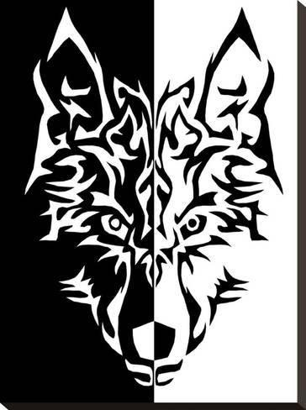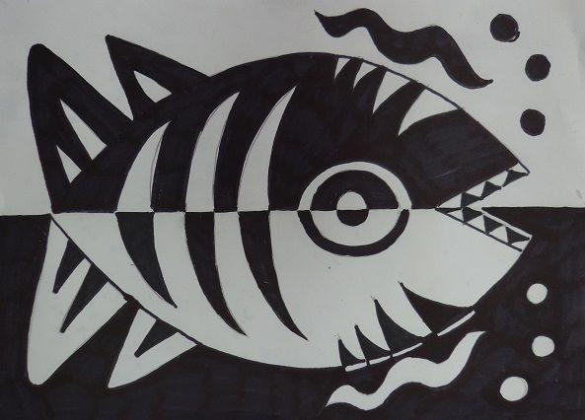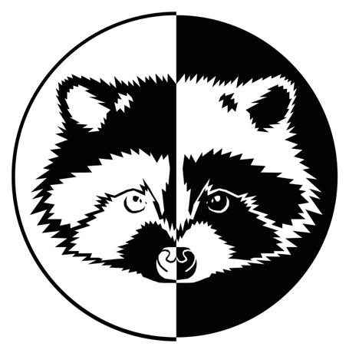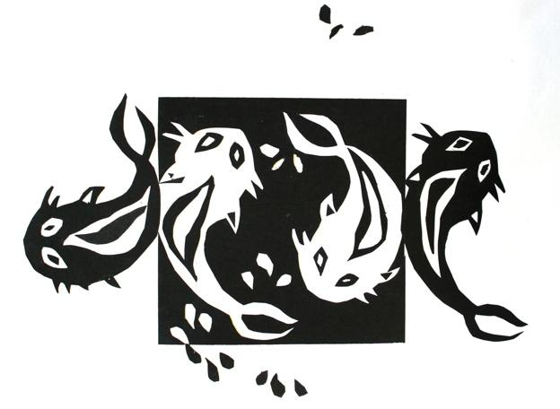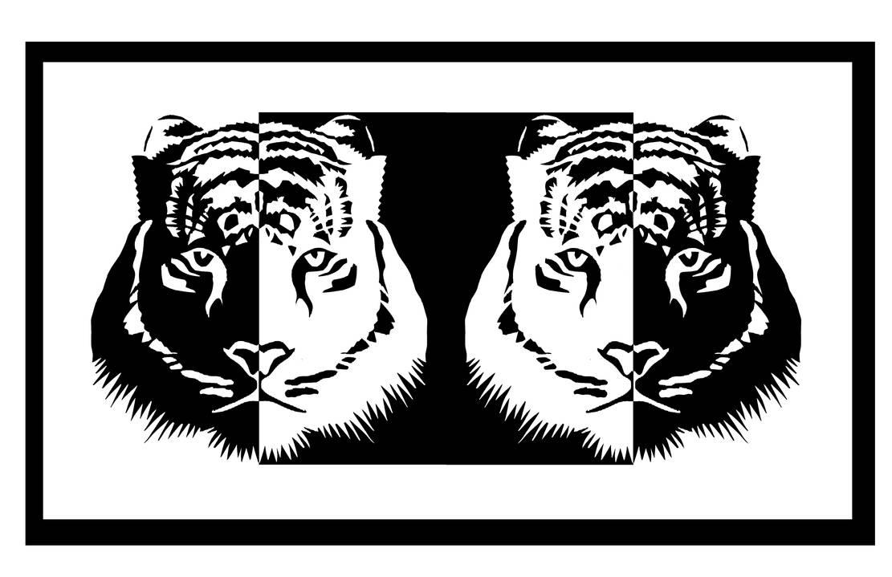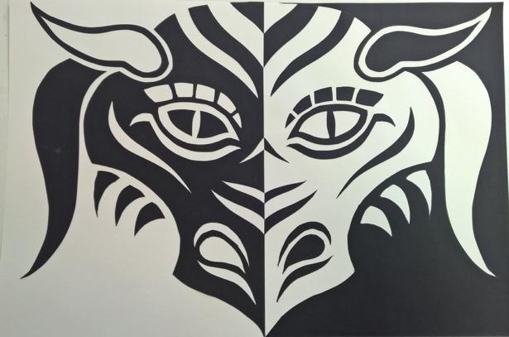

Videos

Color Theory Basics: https://www.youtube.com/watch?v=L1CK9bE3H_s

Positive and Negative Space: Notan Design Tutorial: https://www.youtube.com/watch?v=ZaZuJWL7Z38

Preparation:
What do you need to prepare for this experience? List steps of preparation in a bulleted format.
- Create a clean-up system for washing paintbrushes out.
- Create teacher example (research, thumbnails, and final project)
- Make sure that there are enough palettes for each student. Make sure that the paints are arranged in a way that are easy for students to access them when getting their paints on their palettes.
- Cut illustration boards into 11”x17” size

Do everything 1-2 weeks before the lesson starts.

Safety:

Be specific about the safety procedures that need to be addressed with students. List all safety issue in a bulleted format.
Make sure students have the option of wearing an apron or an old shirt if they are concerned about getting paint on their clothes.
Explain that acrylic is non-toxic and is essentially liquid plastic. When students get paint on their hands, it can easily be washed or peeled off.

Action to motivate/Inquiry Questions:
Describe how you will begin the lesson to stimulate student’s interest. How will you pique their curiosity and make them interested and excited about the lesson? What inquiry questions will you pose? Be specific about what you will say and do to motivate students and get them thinking and ready to participate. Be aware of the varying range of learning styles/intelligences of your students. Some ideas might include: telling a story, posing a series of questions, role-playing, etc.
Class discussion on basic color theory and color schemes:
Make sure that you have a large color wheel displayed in the classroom.
- Complimentary color scheme: colors across from each other on the color wheel, and they make brown when mixed together (red/green, blue/orange, yellow/purple)
- Primary colors: colors you need to mix other colors and cannot be mixed (red, blue, yellow)
- Secondary colors: created by mixing two primary colors together (green, orange, purple)
- Tertiary colors: created by mixing a primary and a secondary color together (red-orange, yellow-green, blue-violet, etc.)
- Split complimentary colors: two tertiary colors and one primary/secondary color that’s a compliment (red and yellow-green/blue-green).
- Monochromatic color scheme: involves different value gradients of one color
- Achromatic color scheme: absence of color (gray scale)

Class discussion: Why does color play such an important role in our world?
- Food industry: fast food vs. nice restaurants
- Directing safety measures like traffic and poison
- Personifies different cultural identities
- Emotional impact, particularly with color psychology (important for fine arts and commercial arts)
- Selling products or buying into a certain message
- Can be healing on a scientific level with wavelengths (color therapy)
- Give the students a chance to come up with their own examples. There’s no wrong answer.

Ideation/Inquiry:
Ideation is the creative process of generating, developing, and communicating new ideas, where an idea is understood as a basic element of thought that can be visual, concrete or abstract. List and describe inquiry questions and processes you will engage students in to help them develop ideas and plans for their artwork.
Part 1: Students will draw three different animal portraits, either front facing and split in half, or two animals mirrored on opposite halves of the composition. The design of the animal can be realistic or have indigenous elements to it.

Part 2: Students pick their favorite composition and create three more thumbnails working with three different color schemes. They must be six colors used in total.
- Option 1: choose a complimentary color scheme. The animal should have at least two colors while the background should have one.
- Option 2: choose a complimentary color scheme. Have one half involve three values of one complimentary color, while the other half has three values of the opposite complimentary color.
- Option 3: choose a tertiary color scheme, which could be analogous, split-complimentary, primary, or secondary colors.

Instruction:
Give a detailed account (in bulleted form) of what you will teach. Be sure to include approximate time for each activity and instructional methodology: skills, lecture, inquiry, etc. Include motivation and ideation/inquiry where appropriate; including what student will understand as a result of the art experience

Week 1 | Instruction - The teacher will... (Be specific about what concepts, information, understandings, etc. will be taught.) Identify instructional methodology. KNOW (Content) and DO (Skill)  Day 1  Goal: paint all primary colors (red, yellow, blue and their tints and shades.  Class discussion on basic color theory and color schemes:  Make sure that you have a large color wheel displayed in the classroom.  - Complimentary color scheme: colors across from each other on the color wheel, and they make brown when mixed together (red/green, blue/orange, yellow/purple)  - Primary colors: colors you need to mix other colors and cannot be mixed (red, blue, yellow)  - Secondary colors: created by mixing two primary colors together (green, orange, purple)  - Tertiary colors: created by mixing a primary and a secondary color together (red-orange, yellow-green, blue-violet, etc.)  - Split complimentary colors: two tertiary colors and one primary/secondary color that’s a compliment (red and yellow-green/blue-green).  - Monochromatic color scheme: involves different value gradients of one color  - Achromatic color scheme: absence of color (gray scale)  Class discussion: Why does color play such an important role in our world?  - Food industry: fast food vs. nice restaurants  - Directing safety measures like traffic and poison  - Personifies different cultural identities  - Emotional impact, particularly with color psychology (important for fine arts and commercial arts)  - Selling products or buying into a certain message  - Can be healing on a scientific level with wavelengths (color therapy)  - Give the students a chance to come up with their own examples. There’s no wrong answer.  Demonstration on how to create a color wheel.  - Talk about acrylic paint and how it’s different from other kinds of paint. It’s essentially liquid plastic that dries quickly. It’s non-toxic and peels off skin, but it will stain clothes if it’s not washed off quickly. Students have the option of bringing in aprons or old t-shirts in case.  - Get the students to come up and demo mixing.  - Give students a template to draw the color wheel on their illustration board—pass out a blank color wheel template. Students will color the back of them with graphite and trace over them onto their illustration board. Teacher should do this in advance to save time during demonstration.  - Paint the primary colors. Mix tints by adding white with a little bit of color. Mix shades by adding a little bit of black to the color (explain that black will make colors more blue, and burnt umber or dark purple can make things look more lively).  - With white, add a small dollop of color into the white mixture. If students mix a bunch of white into the color, it will end up wasting paint.  - With black, add a small dollop of it to a color. A little goes a long way.  Work Time:  - Goal: paint all primary colors and their tints/shades. If students are finished with that, they can begin mixing their secondary colors.  Go over clean-up procedures for acrylic paints.  - Squirt soap into hands and brush the paintbrush vigorously into the palm. Do this until there aren’t anymore paint streaks.  - Wash out the paint palettes completely.  - Think about classroom management strategy for washing paintbrushes: either numbering tables, having students be responsible for washing all brushes and palettes (trading off), or having buckets brought in. Give the students voting rights to see how this could be done effectively.  Day 2  Demonstration on how to mix secondary and tertiary colors.  - Have students come up and demo this process.  Work Day.  Clean-Up:  Goal: finish primary colors and their tints and shades. Begin secondary colors and their tints and shades.  Day 3  Work Day  Clean-Up:  Goal: finish full color wheel.  Day 4  Goal: begin working on painted value scales.  Demonstration on how to mix a black and white value scale.  - Start with white, black, and mid-tone gray.  - Work in between values by mixing. Experiment with seeing how smoothly the transitions look.  - Have the teacher demo value scale already started and filling in the in-between values.  - The values for the color scale should match the values for the black and white scale. The way students can do this is by squinting and comparing the values side-by-side.  - Important note: just because a red out of the tube is the base color doesn’t mean that it goes in the mid-tone gray spot. It might be lighter or darker. One suggestion is to have all of the colors mixed on the palette before painting to see the flow.  Work Day  Clean-Up  Day 5  Goal: value scales should be done for both black/white and color.  Work Day  Clean-up | Learning - Students will... i.e.: explore ideation by making connections,  comparing, contrasting; synthesize possibilities for each painting technique; etc. (Be specific about what will be the intended result of the instruction as it relates to learning.) UNDERSTAND | Time  10 min.  10 min.  15 min.  15 min.  5 min.  35 min.  10 min.  40 min.  10 min.  5 min.  35 min.  10 min.  40 min.  10 min.
Week 2 | Day 1  Goal: all thumbnail sketches should be finished by the end of class.  Introduce the lesson. Pass out worksheets.  - Ask students what a notan drawing is before they see the examples.  Thumbnail sketches  - Students can draw half of an animal’s face or mirror two silhouettes of the animal. Bilateral symmetry is key (explain what that is and have students guess it).  - Students can have either cultural designs or go for realism.  - Students must draw their designs, pick their favorite, and do three different color schemes for that one design. There will be six thumbnails in total.  - Make sure the students have access to color material, preferably colored pencils  Work Time  Clean-Up  Day 2  Goal: Finish thumbnails, get animal drawing transferred onto illustration board, and begin painting.  Demonstration: drawing half of animal face  - Measure how the shape of the illustration board (make sure students put tape around the borders. Draw a pencil line that cuts the board in half. Do this process with the students to make sure they are doing it right. Get out a pencil, ruler, and tape.  - Get paper that measures out the exact half of the illustration board. Draw one half of the animal. Trace it on both sides by taking it to the window.  - Use the graphite/charcoal transfer process. Color the back of the drawing and trace over the part of the drawing you want on the other side. Go over those tracing marks.  Work Day:  - Finish thumbnails, transfer the drawing onto the illustration board, and start painting.  Clean-up  Day 3  Work Day.  Clean-up  Day 4  Work Day.  Clean-Up  Day 5  Work Day.  Clean-Up  Goal: project is 50% finished. |  | 5 min.  40 min.  5 min.  7 min.  38 min.  5 min. (unless students are painting, which should be 10 min.)  40 min.  10 min.  40 min.  10 min.  40 min.  10 min.
Week 3 | Day 1  Work Day.  Clean-Up  Day 2  Work Day.  Clean-Up  Goal: project is 75-80% finished.  Day 3  Work Day.  Clean-Up  Day 4  Work Day.  Clean-Up  Goal: project is completely finished.  Day 5  Critique Day  Start off with a gallery walk of everyone’s projects.  Group Critique  - Students will get into their groups based on the genus of their animals.  - Fill out the critique worksheet  - Come together for group discussion  Feedback on the lesson and Ms. N’s teaching style.  - Write down feedback  - Talk about it as a group |  | 40 min.  10 min.  40 min.  10 min.  40 min.  10 min.  40 min.  10 min.  30 min. total  25 min.

Student reflective/inquiry activity:
Sample questions and activities (i.e. games, gallery walk, artist statement, interview) intended to promote deeper thinking, reflection and refined understandings precisely related to the grade level expectations. How will students reflect on their learning? A participatory activity that includes students in finding meaning, inquiring about materials and techniques and reflecting about their experience as it relates to objectives, standards and grade level expectations of the lesson.)
After students are finished with their projects, they will group up based on the genus of their animals. In small groups, they will fill out a critique worksheet that provides discussion questions about the body of work. All students are required to fill out the sheet. Once they are finished, we will come together as a class to discuss the answers.

Questions:
- What do all the animals in this body of work have in common with each other?
- What color scheme predominantly shows up with this group of work? Are there more warm or cool colors? Are there more complimentary color schemes or primary/secondary?
- How do you think color impacts the expression of these animals? Do you think that the color accurately reflects the emotional expression of the animals?
- What do you think are some technical strengths of this group of work? Think about the collective, not pointing out individual artists.
- What are some suggestions you have to improve this group of work, either technically or conceptually? Again, this is not about pointing out individual artists. This is about making a collective group agreement about how the lesson could be pushed to a more advanced degree.

Post-Assessment (teacher-centered/objectives as questions):  Have students achieved the objectives and grade level expectations specified in your lesson plan? | Post-Assessment Instrument:  How well have students achieved the objectives and grade level expectations specified in your lesson plan? Include your rubric, checklist, rating scale, etc.
Can students construct a color wheel using acrylic paint?

Can students design three thumbnail sketches of different notan animals with three different color schemes?

Can students create their final notan animal portrait painting using acrylic paints?

Can students assess how color affects the expression of the animal portraits using the critique worksheet?

Self-Reflection:
After the lesson is concluded write a brief reflection of what went well, what surprised you, and what you would do differently. Specifically address: (1) To what extent were lesson objectives achieved? (Utilize assessment data to justify your level of achievement.) (2) What changes, omissions, or additions to the lesson would you make if you were to teach again? (3)What do you envision for the next lesson? (Continued practice, reteach content, etc.)
Strengths

Process
- Assistance with teaching how to paint
- Learning about symmetry, especially with animal portraits
- How the color scheme brought everything together at the end.
- Enjoyed the color mixing process
- Lesson on color theory was successful

Product
- Emphasis on the background caused more problem-solving
- Choosing from multiple color schemes and that everything had to be the opposite
- Freedom of choice for animals
- Good final example for the students
- Freedom of choice for the color schemes, even though they were restricted
Critique

Classroom Management
- Available for help, and answered questions well
- Gave plenty of time for clean-up
- Got the class to listen and follow directions
- Did a good job making myself available for helping students out
- Room was overall kept pretty clean
- Taught the class in a calm way
- Healthy balance between giving a helpful critique but also giving creative freedom for the students to make whatever choices they wanted

Areas of Growth

Process
- More clarity on how to blend and shade
- Showing different painting techniques to make the painting more interesting
- More clarity on how much paint to get and how to mix the paint to create other colors
- More specificity on how to make things more symmetrical and even
- More thorough explanation on color combinations
- More specific expectations on the project and making sure everyone was on the same page
- More direction on how colors are coordinated
- Help students plan out for shading the animal
- Talk about the history of notan art in greater depth
- Teach how to make crisp lines
Product
- Flexibility with color schemes
- Suggestion of using people rather than animals
- Challenge to mix colors to appear realistically to the animal
- Suggestion to use canvas instead of illustration board

Critique

Classroom Management
- Could have been more helpful with individual help instead of being gone and letting us “problem-solve” on our own. She could have gone around and told us ways to improve our project.
- Be more clear about expectations
- Have a better accountability strategy for cleaning brushes and making sure everything was put away correctly
- Circulate the room more to help other students and provide more direction to those that really need it
- Give students a sheet of paper towel rather than letting them pick out how much they want

Appendix: Include all handouts, prompts, written materials, rubrics, etc. that will be given to students.

8/9/15 Fahey

