Lesson 2: Advanced Linear Perspective Project Artistic Research

Name: Ms. Niederman
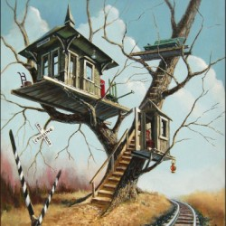

What theme does your treehouse have? What time period does it take place in? Who is allowed to go into the tree house? Is it daytime or nighttime?

- There’s a sort of whimsical, dreamlike contemporary style to it. It was something I saw in one of my dreams.
- Nighttime
- Anyone can go into the treehouse, as long as they are light on their feet.
- There’s no specific time period, as dream states alter the reality of time.

What are you going to do to your treehouse to make it look original or different from other treehouses? How are you going to make it look exciting enough for someone to go inside it?

- There are multiple levels to the treehouse, kind of like villas. I like the idea of a multi-tiered treehouse. I don’t want the buildings to be too detailed because it’s in a surreal dream environment. They only become more detailed when people come close to it, and they can make the houses whatever they want them to be. I want the texture of the houses to represent the personality of the building: complexly intertwined.
- The appeal is that people can manipulate what the building looks like from the inside with their subconscious mind.

Copy and paste reference photos that would inspire the theme and exterior structure of your treehouse.

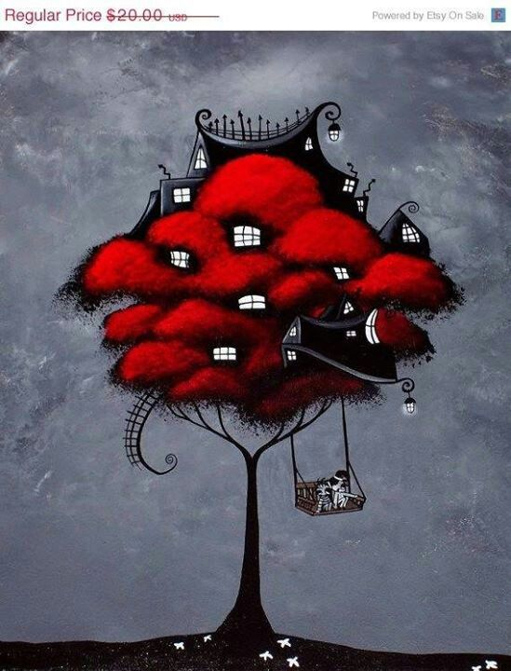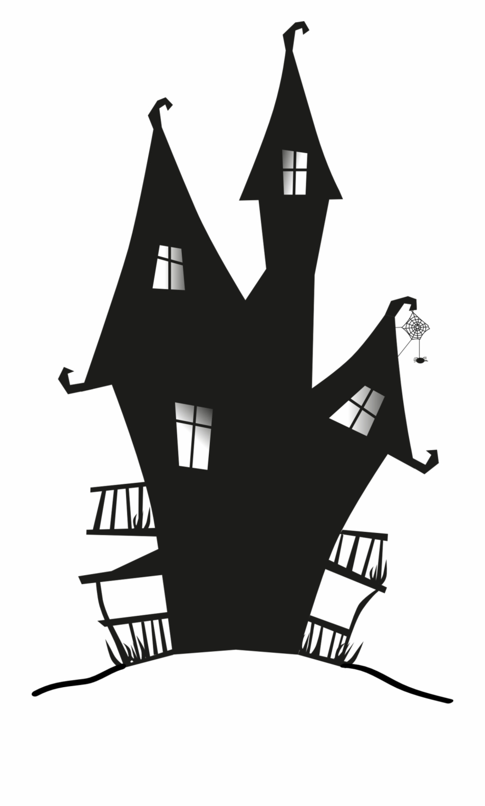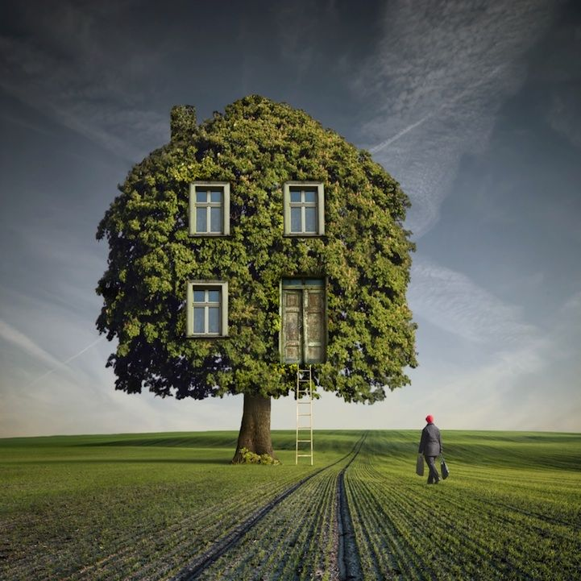
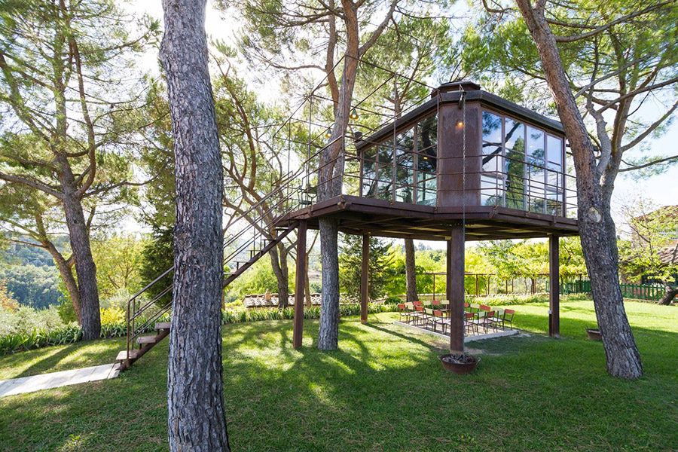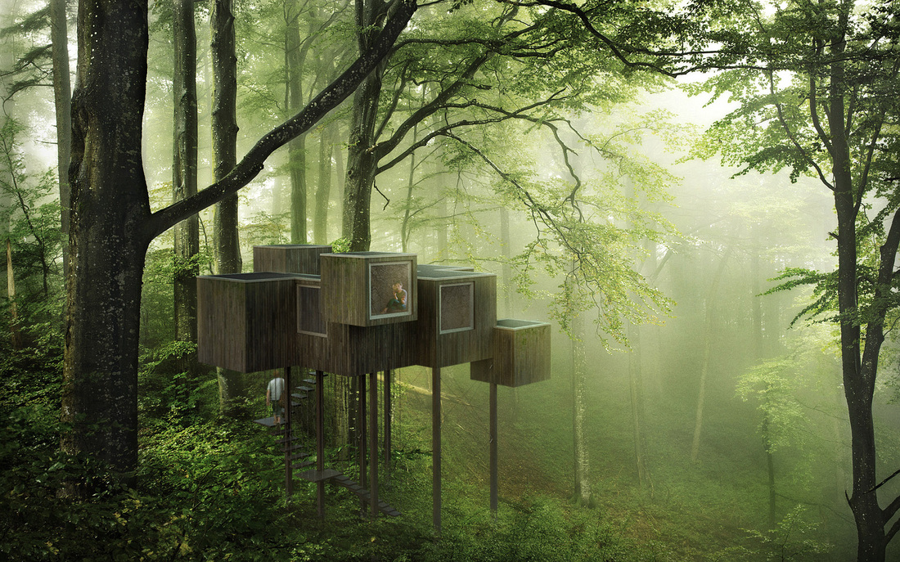

Draw the basic design for your treehouse and what kind of tree you picture it sitting in.

