Character Design Worksheet

Name: Ms. Niederman

Circle or highlight the options you’re choosing for your project:

Materials | Technical Presentation | Conceptual Presentation
Option 1: Graphite or pen/ink shading on drawing paper  Option 2: a light wash of acrylic paint with pen/ink or graphite on illustration board | Option 1: Create one realistic character.  *Note: a background is optional, but highly recommended if you plan to include this piece for your AP Studio portfolio. If you choose this option and still want to have a background, I will only give you feedback on the character design and critique your background for AP Studio.  Option 2: Create a simplified, cartoonish character with at least six different gesture drawings on a blank background. | Option 1: Create a mythical creature that relates to a natural or manmade element (wind, water, fire, earth, thunder/electricity, steel, etc.)  Option 2: Create a superhero or video game character (arcade fighting, JRPG, etc.) with special abilities, costumes, and weapons  Option 3: Create a character that represents the mascot of a business (such as a skater or energy drink company) or sports team (must be an original design)  Option 4: Create a proposal for your own character design approach (must get approved by Ms. N)

Artistic Research

Insert at least 3-4 images that reference the drawing style and poses that inspire your character. This could be from cartoons, anime, comics, movies, posters, ads, etc.

Gestures Reference
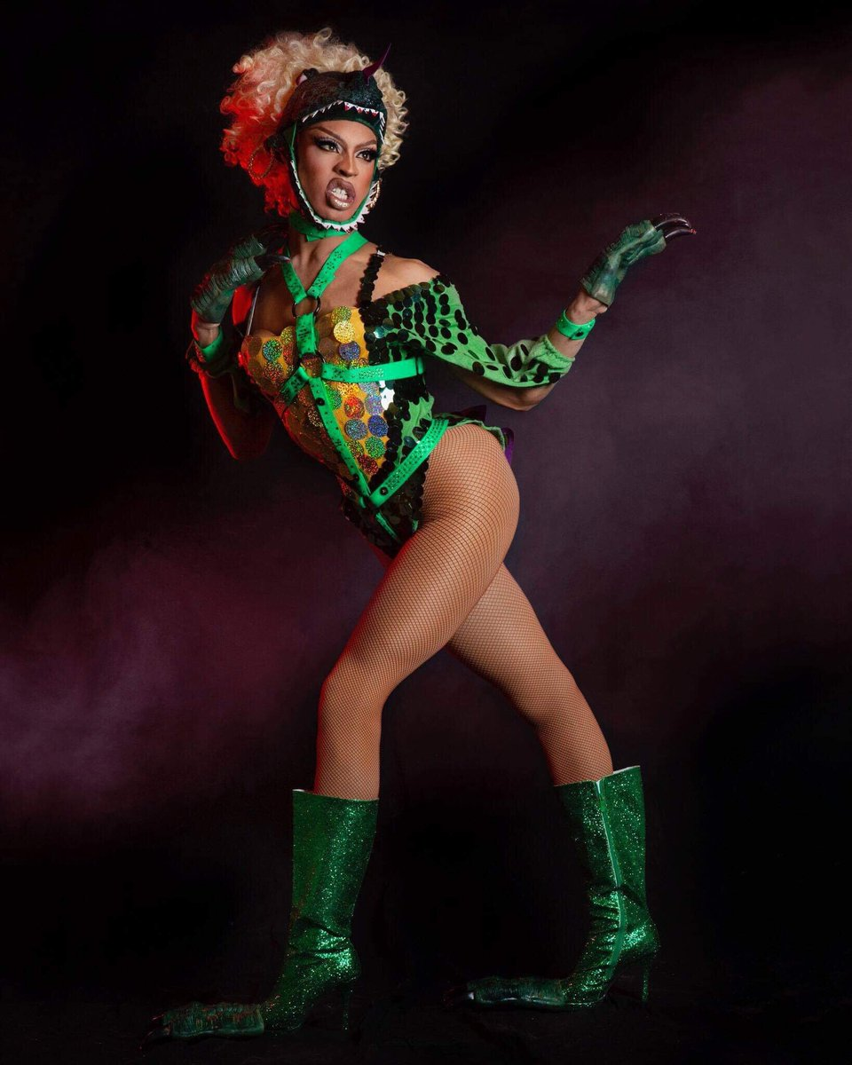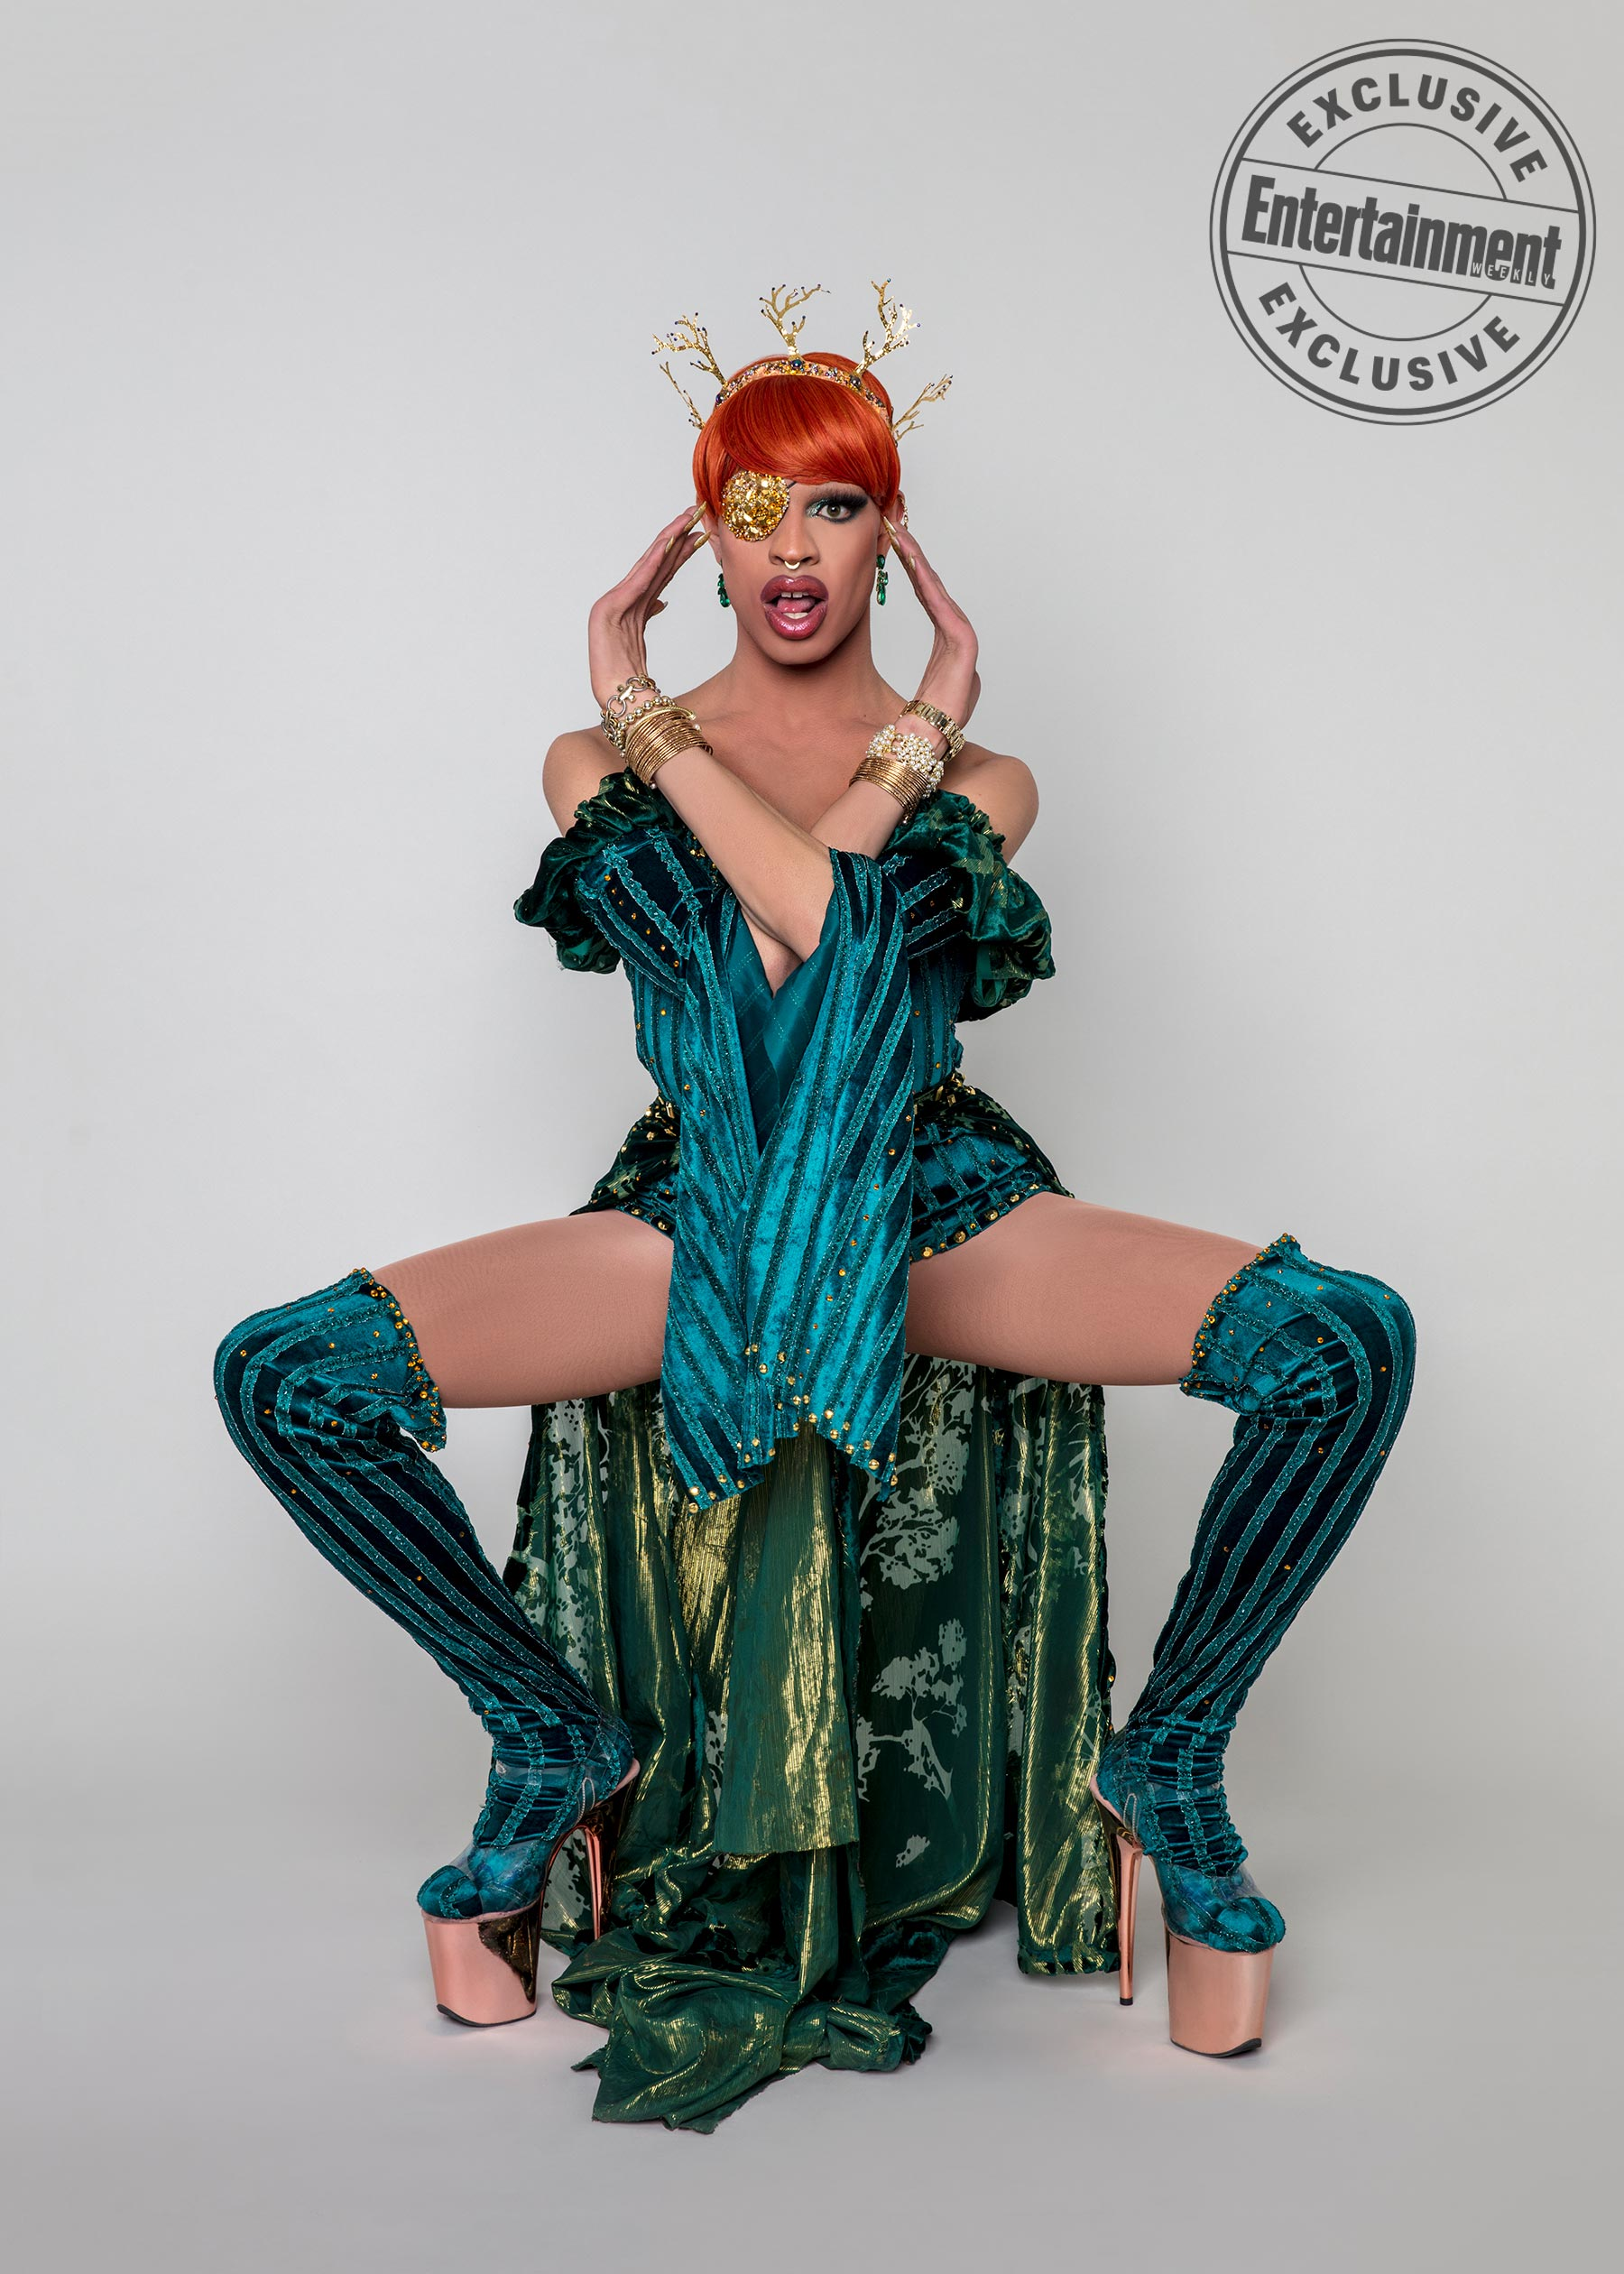
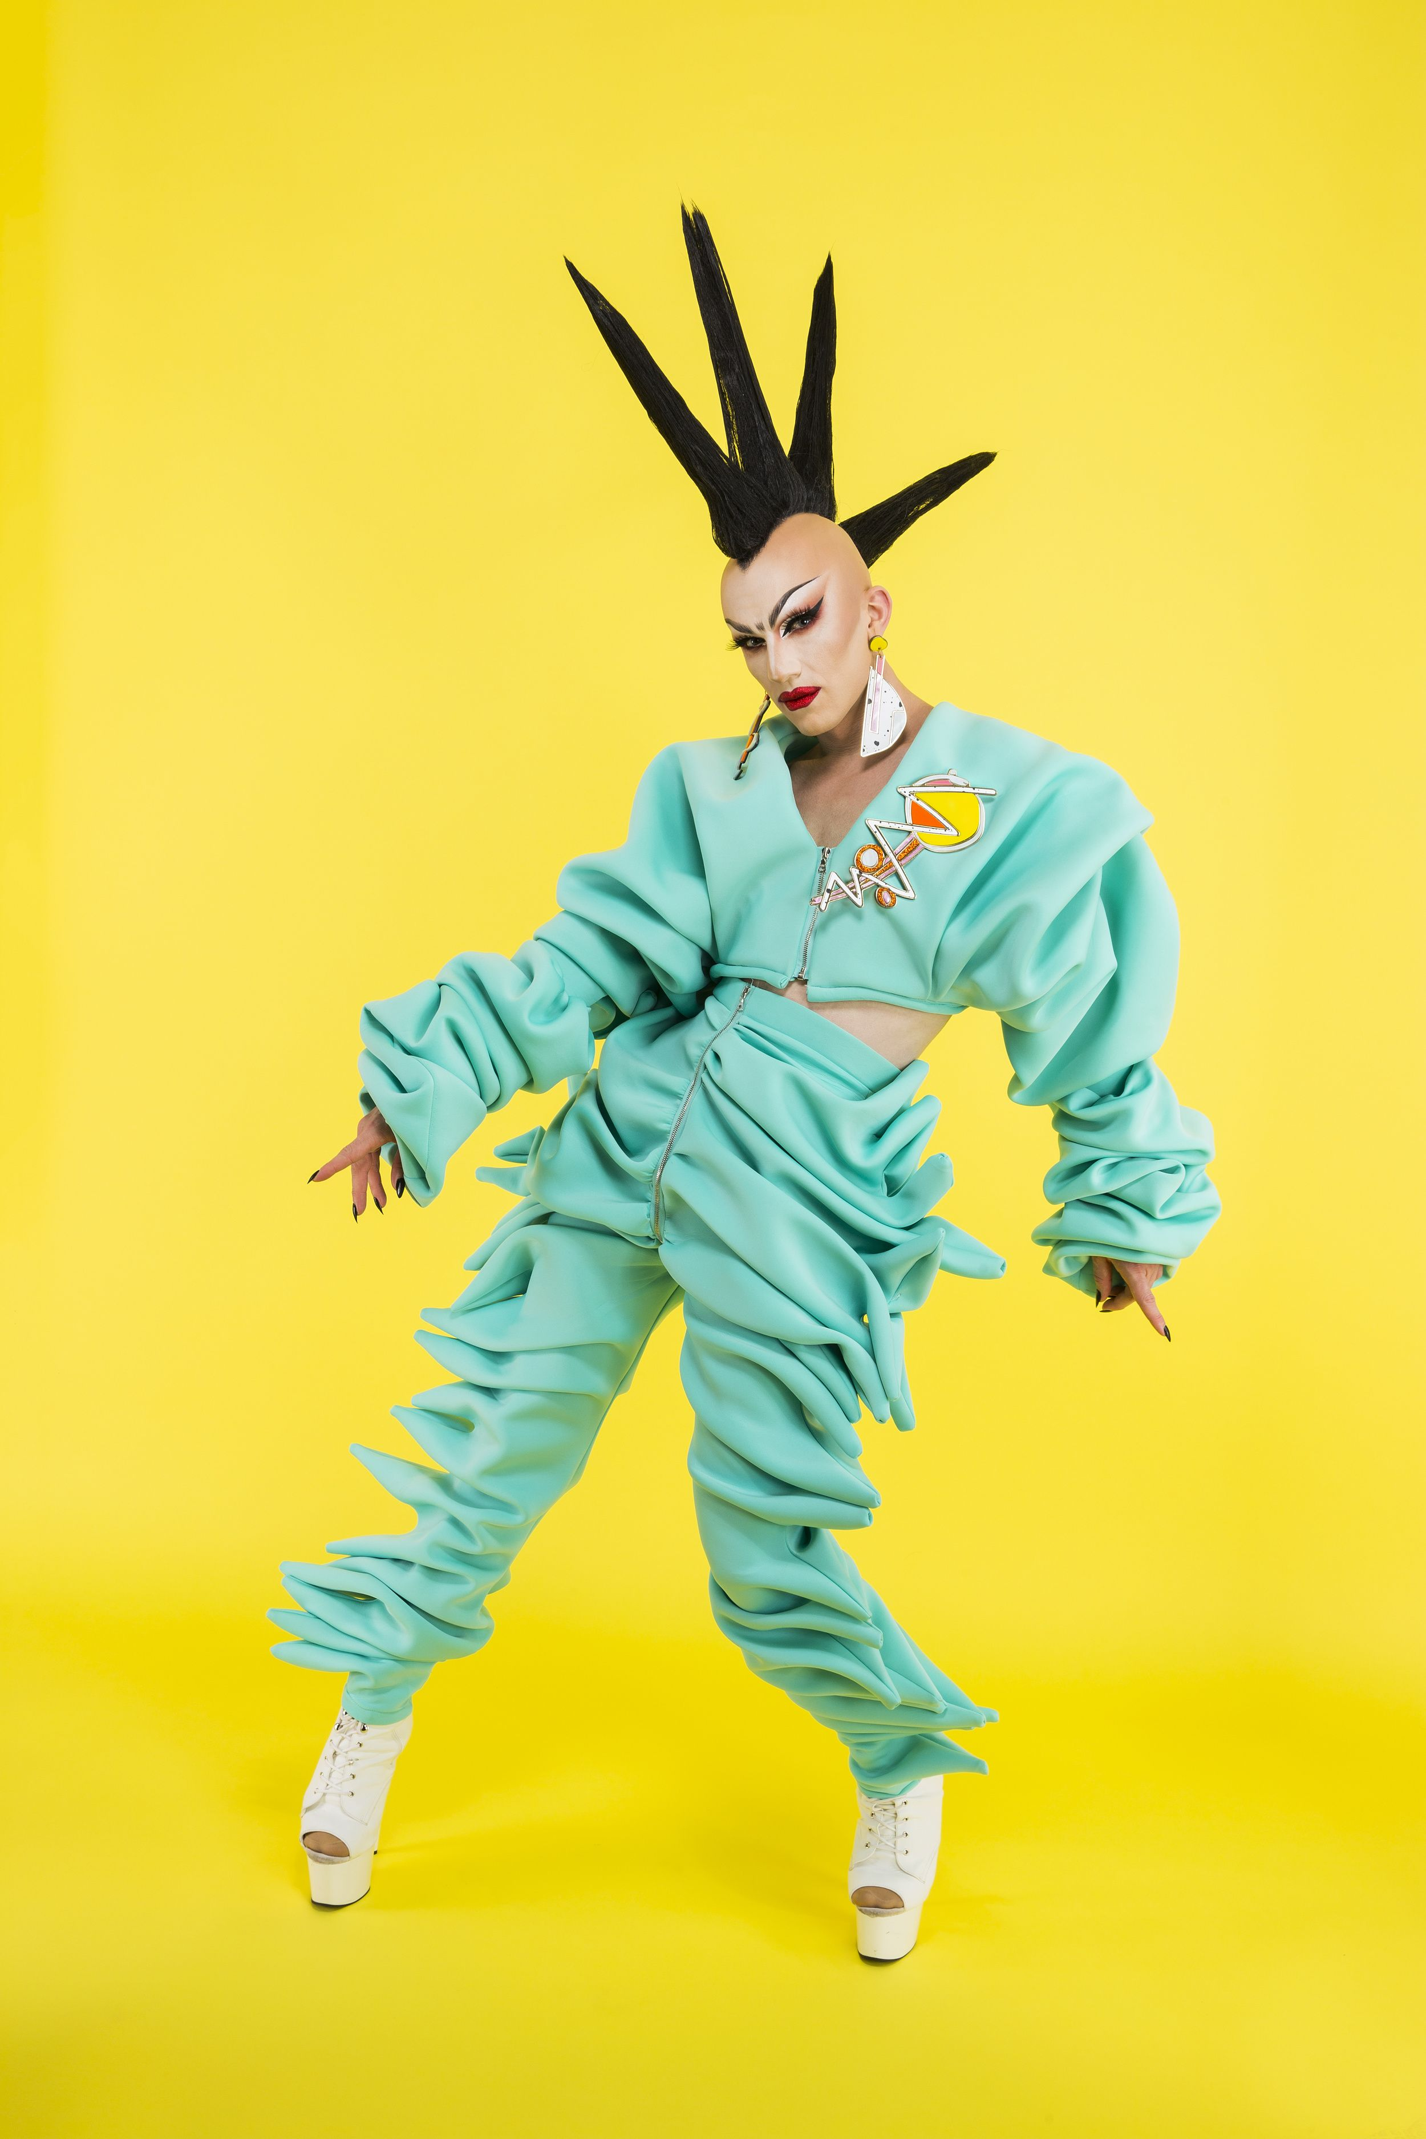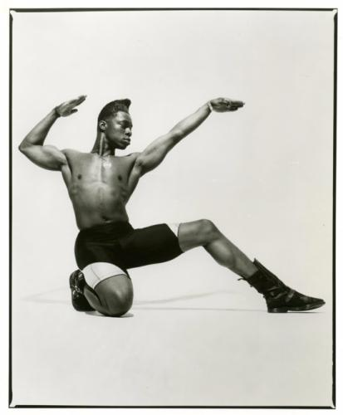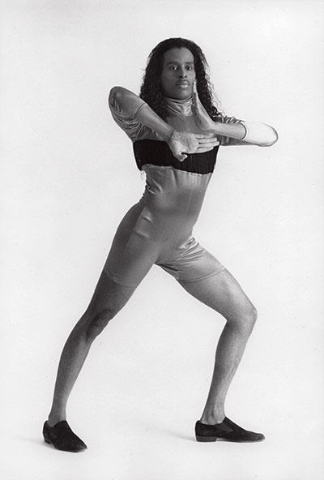

Costume Design Reference
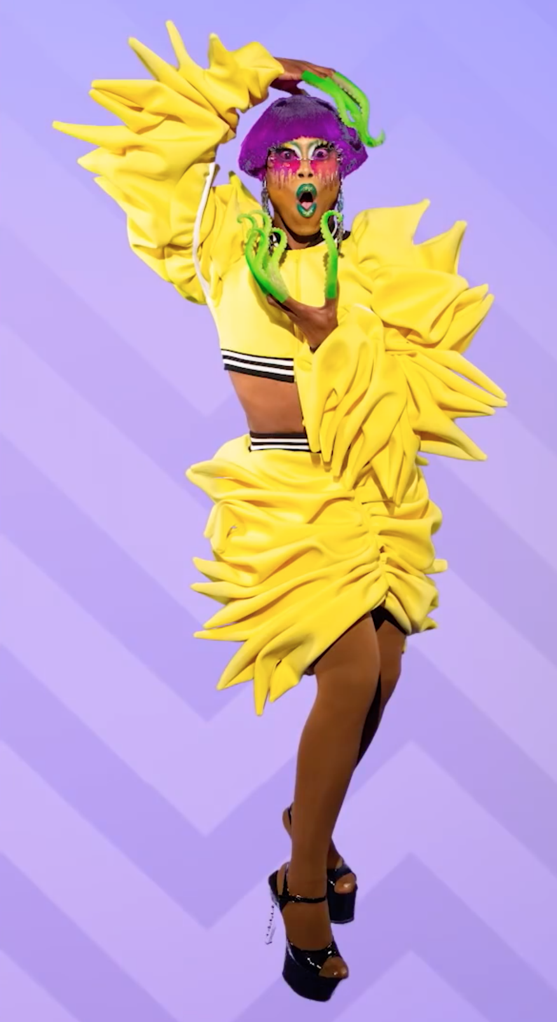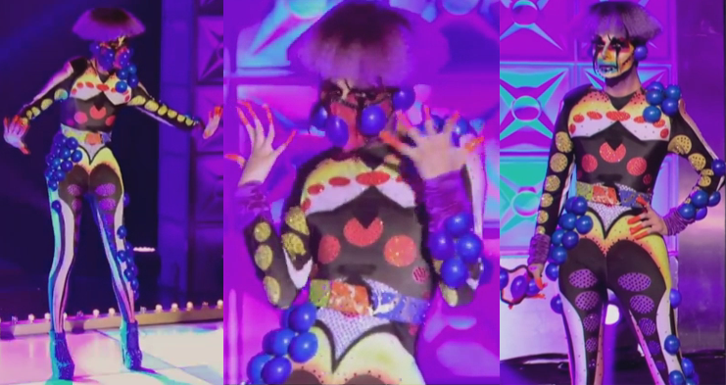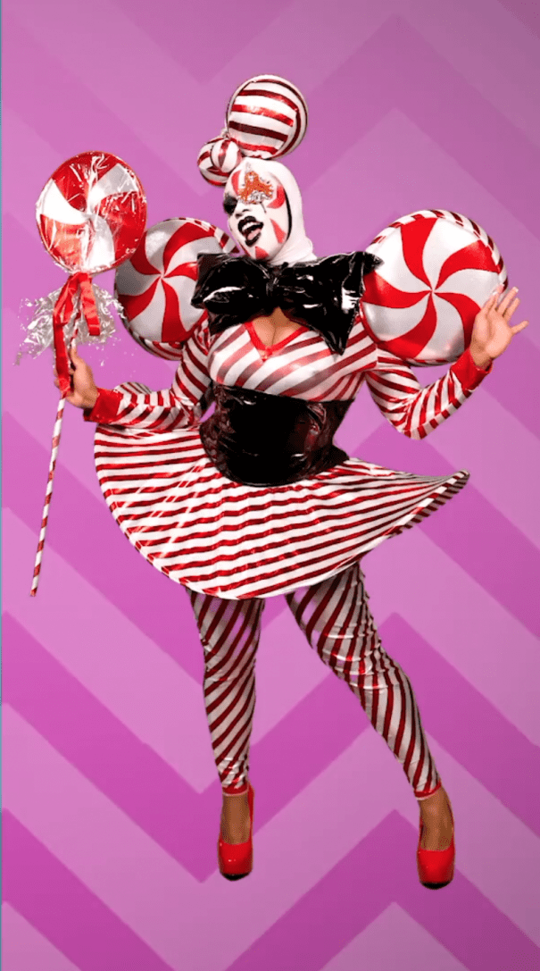

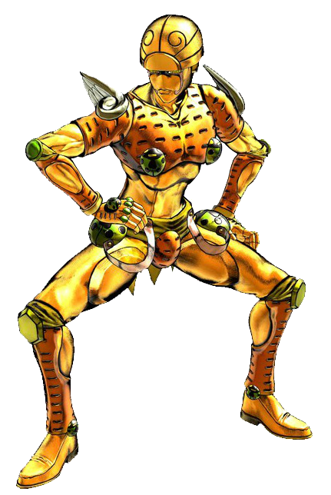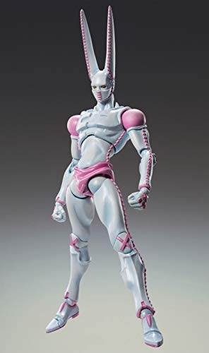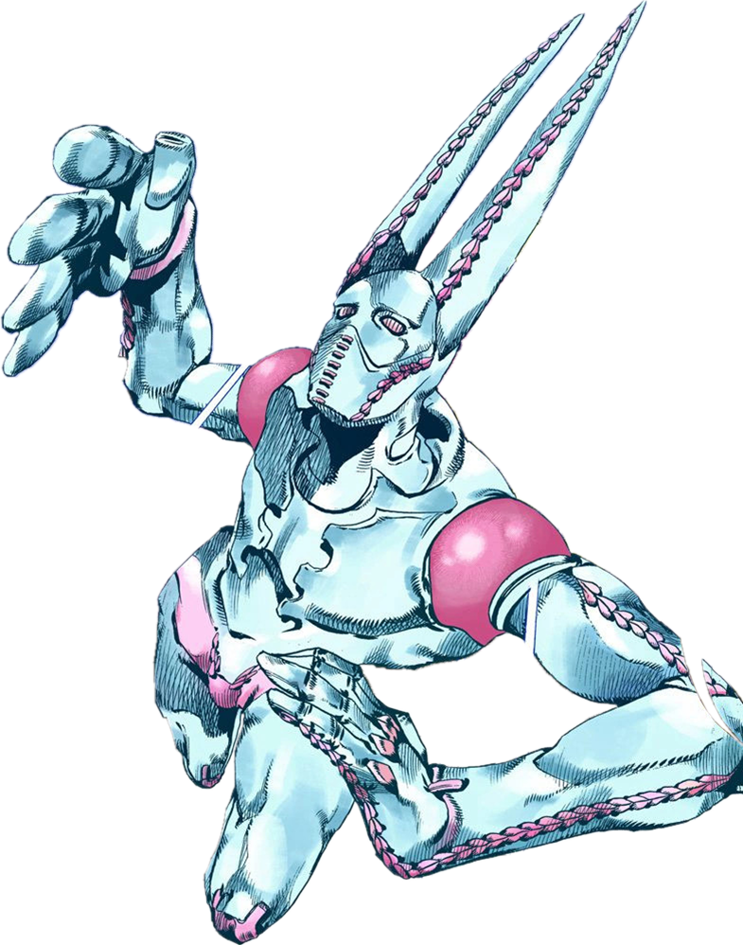
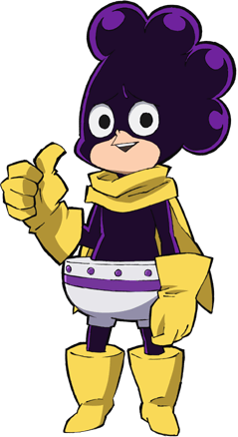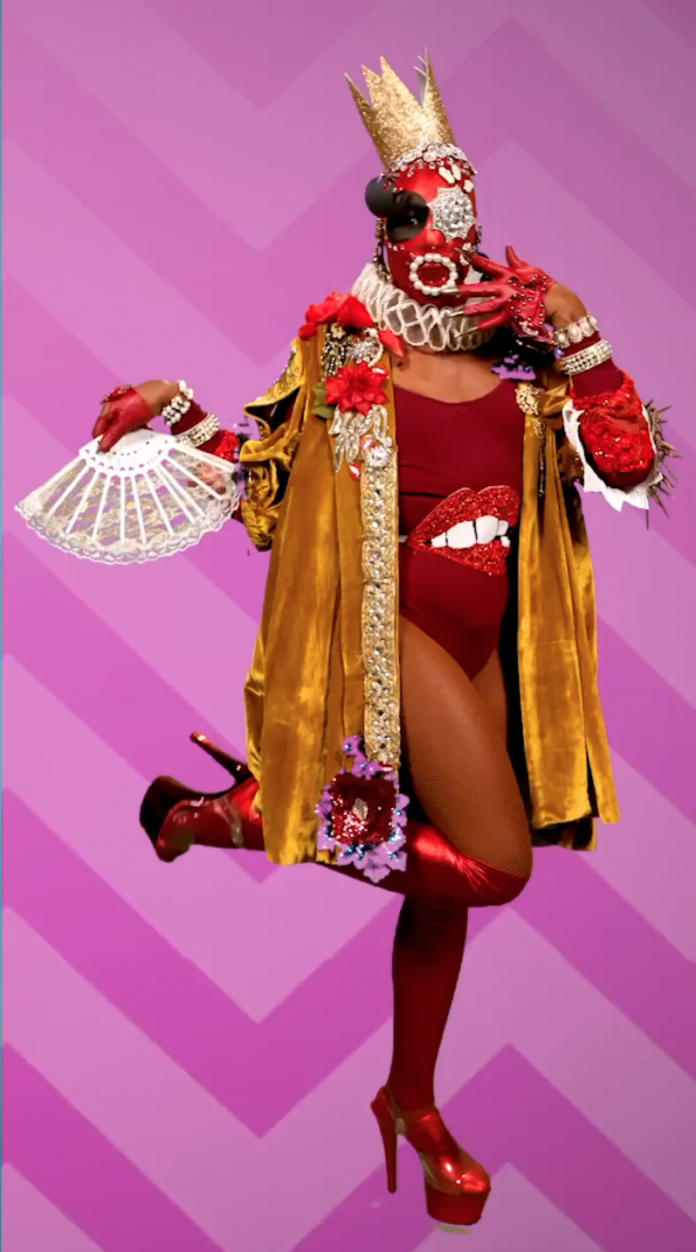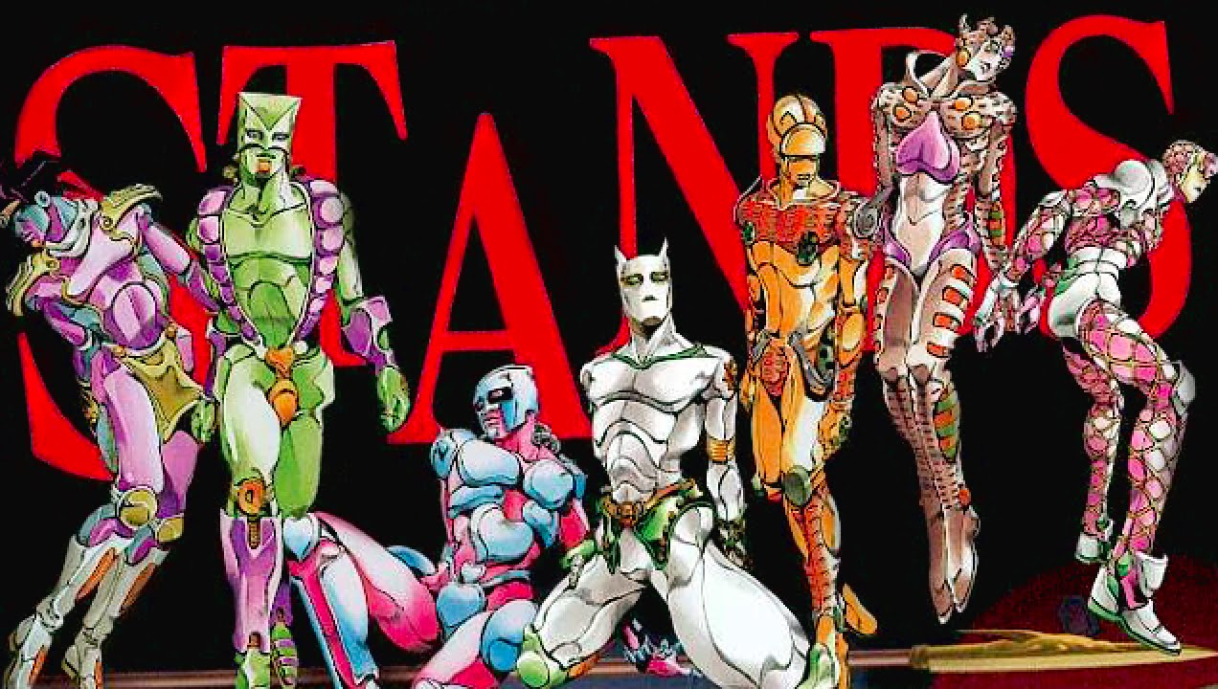
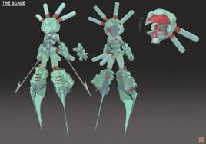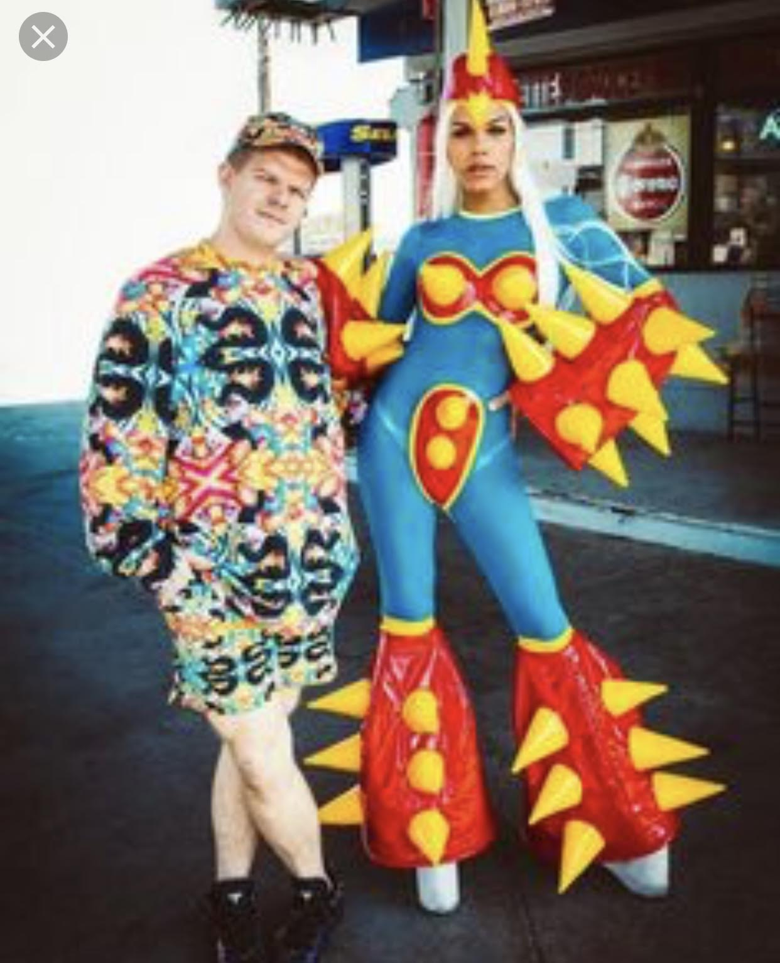

Character Questionnaire

Name of your character: Fantasmo

Gender (all gender identities are welcome and acceptable): Gender Fluid/Androgynous

Age: No age

Describe your character’s physical appearance. What features make your character unique or stand out?
- Tech-tonic robotic style
- Dub-step DJ style
- Curvy despite not being human
- Humanistic proportions
- One eye has long lashes. The other has a hypnotic spiral.
- Hips have stereos and gas mask for face has microphone to amplify voice.

Describe your character’s clothing/costume (textures, style, color, etc.). What features make your character unique or stand out?
- Heavy influence on dubstep/electronic music DJ equipment and style aesthetics
- Club Kid Culture (fashion and performance)
- Lots of shiny, colorful metal and plastic.

How would you describe your character’s personality?
- Likes having fun and interacting with people, even though Fantasmo is a cyborg
- Has a sense of humor and likes to prank people
- During combat, Fantasmo is sneaky, sassy, and confrontational
- Fantasmo is nonverbal due to a combat injury from removing voice. Their voice was replaced, but the voice is very distorted.
- Fantasmo has a strong sense of injustice and feels a tremendous amount of empathy for social justice riots. Nonverbal expression involves music and dance, sometimes urban art. Fantasmo likes to be seen as an image of social justice reform and pop culture art influence.
- Fantasmo can feel empathy and has an independent identity, even though they were created by a human.
- Fantasmo has a creator, though the identity of the creator is unknown. Fantasmo feels like an adopted child. They feel somewhat lost without finding their creator and wants to find him/her, but is able to have a rewarding independent life. Since Fantasmo is a cyborg, they have human feelings but have no memory of a human past.

How does your character’s personality affect the way he/she/they/it moves? Use adjectives to describe your character’s poses. Or draw small doodles of the way you picture your character moving.
- Gestural poses based on club kid performance, voguing, and drag queen modeling
- Robotically quirky and expressive
- Angles with arms and legs to create expressive pose
- Sassy attitude conveyed through body poses
- Emotions mainly expressed through body rather than face

Does your character have any special powers or abilities? If so, describe what they are.
- Gas mask functions both as a protective agent during toxic environments and projects voice using microphones and hip stereos.
- Can summon lightning balls and produces static electricity when touching something
- Sonic booms created from microphone and stereos create noise disturbance during combat

Does your character have a backstory? If so, explain.
- See personality section.

What movie, comic, TV show, video game, or business franchise universe would your character most likely be part of?
- Jojo’s Bizarre Adventures (particularly the stands)
- Furi (video game)
- Club Kid and Drag Queen Culture (particularly vogue dancing)—Rupaul’s Drag Race
- Arcade Fighting Game (Tekken)

Thumbnail Sketches Part 1:

Draw a “rigged” silhouette of your character. Essentially, it’s a straight pose with raised arms that animators create as a prototype.
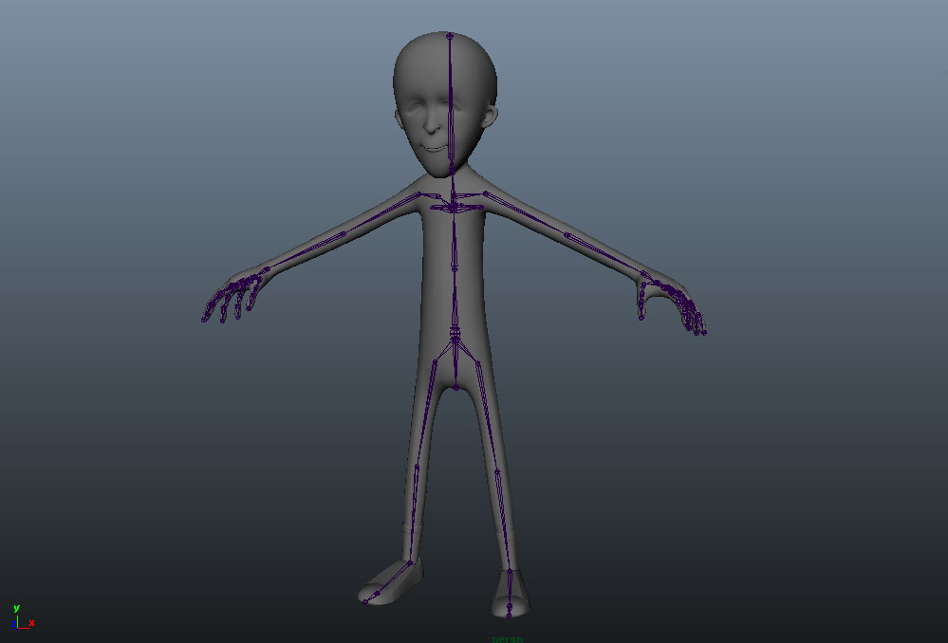

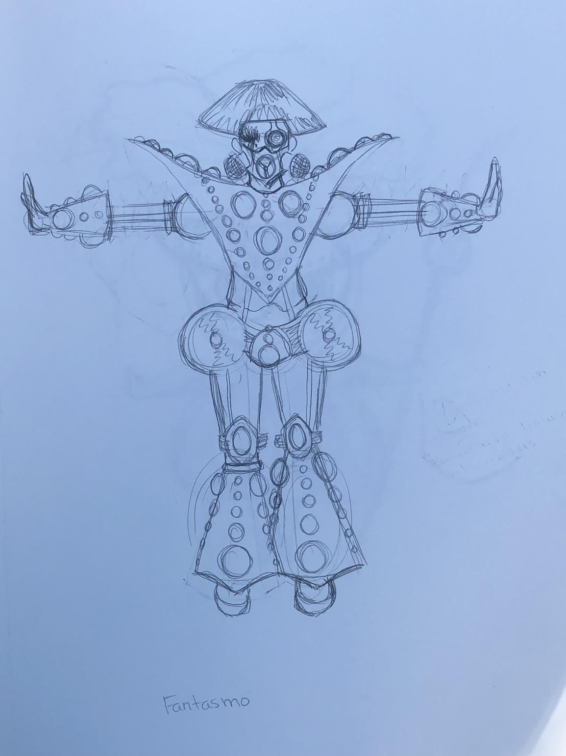

Thumbnail Sketches Part 2:

If you chose the realistic character approach, make seven gesture/action poses your character would make, with three of them being more detailed sketches. Circle the one that you would like to use for your final project.

If you chose the cartoony character approach, make seven gesture/action poses your character would make. Circle five of your favorite poses that you would like to use for your final project. Star the one that is your favorite pose.

Note: Do not worry about drawing specific character details for this part. Just focus on the gesture. Really think about planning positive and negative space in your poses.

