Character Design Worksheet

Name: Ms. Niederman

Circle or highlight the options you’re choosing for your project:

Materials | Technical Presentation | Conceptual Presentation
Option 1: Graphite or pen/ink shading on drawing paper  Option 2: a light wash of acrylic paint with pen/ink or graphite on illustration board | Option 1: Create one realistic character.  *Note: a background is optional, but highly recommended if you plan to include this piece for your AP Studio portfolio. If you choose this option and still want to have a background, I will only give you feedback on the character design and critique your background for AP Studio.  Option 2: Create a simplified, cartoonish character with at least six different gesture drawings on a blank background. | Option 1: Create a mythical creature that relates to a natural or manmade element (wind, water, fire, earth, thunder/electricity, steel, etc.)  Option 2: Create a superhero or video game character (arcade fighting, JRPG, etc.) with special abilities, costumes, and weapons  Option 3: Create a character that represents the mascot of a business (such as a skater or energy drink company) or sports team (must be an original design)  Option 4: Create a proposal for your own character design approach (must get approved by Ms. N)

Artistic Research

Insert at least 3-4 images that reference the drawing style and poses that inspire your character. This could be from cartoons, anime, comics, movies, posters, ads, etc.

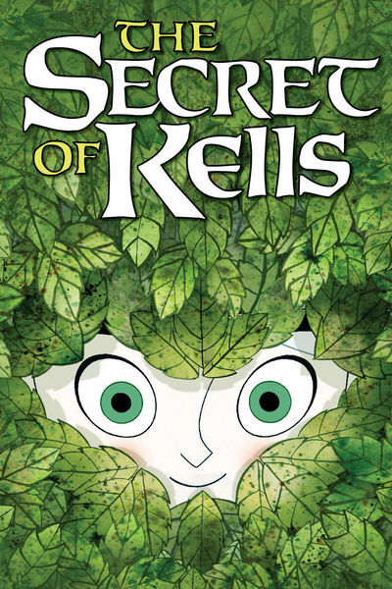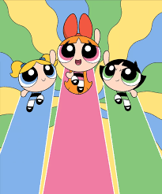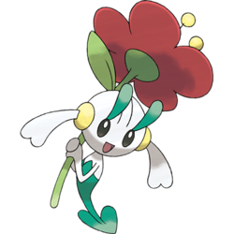

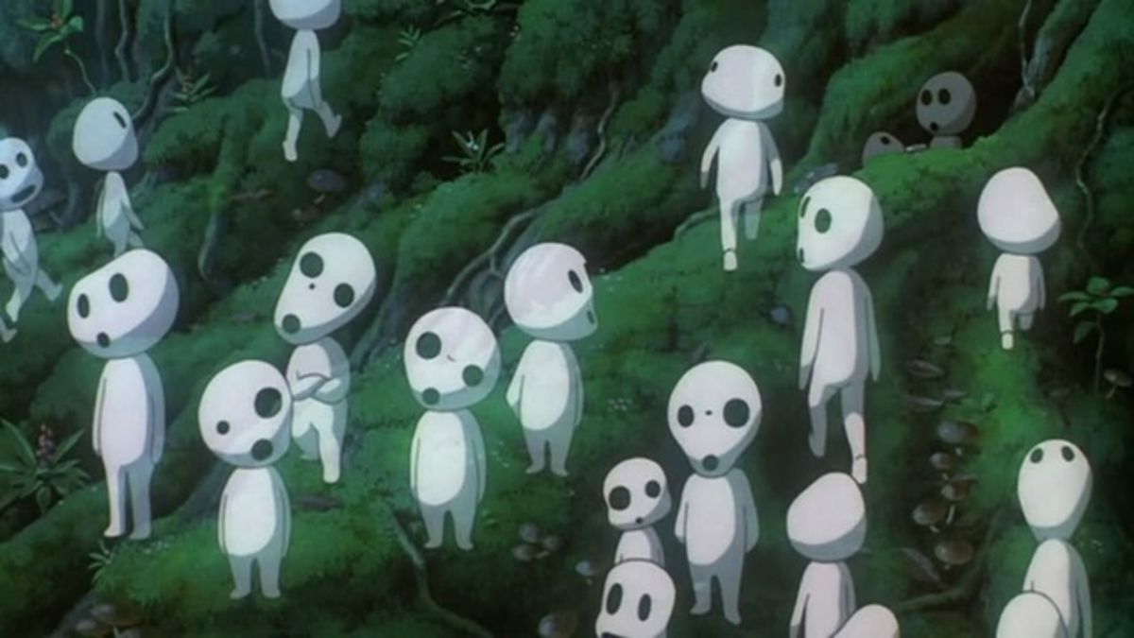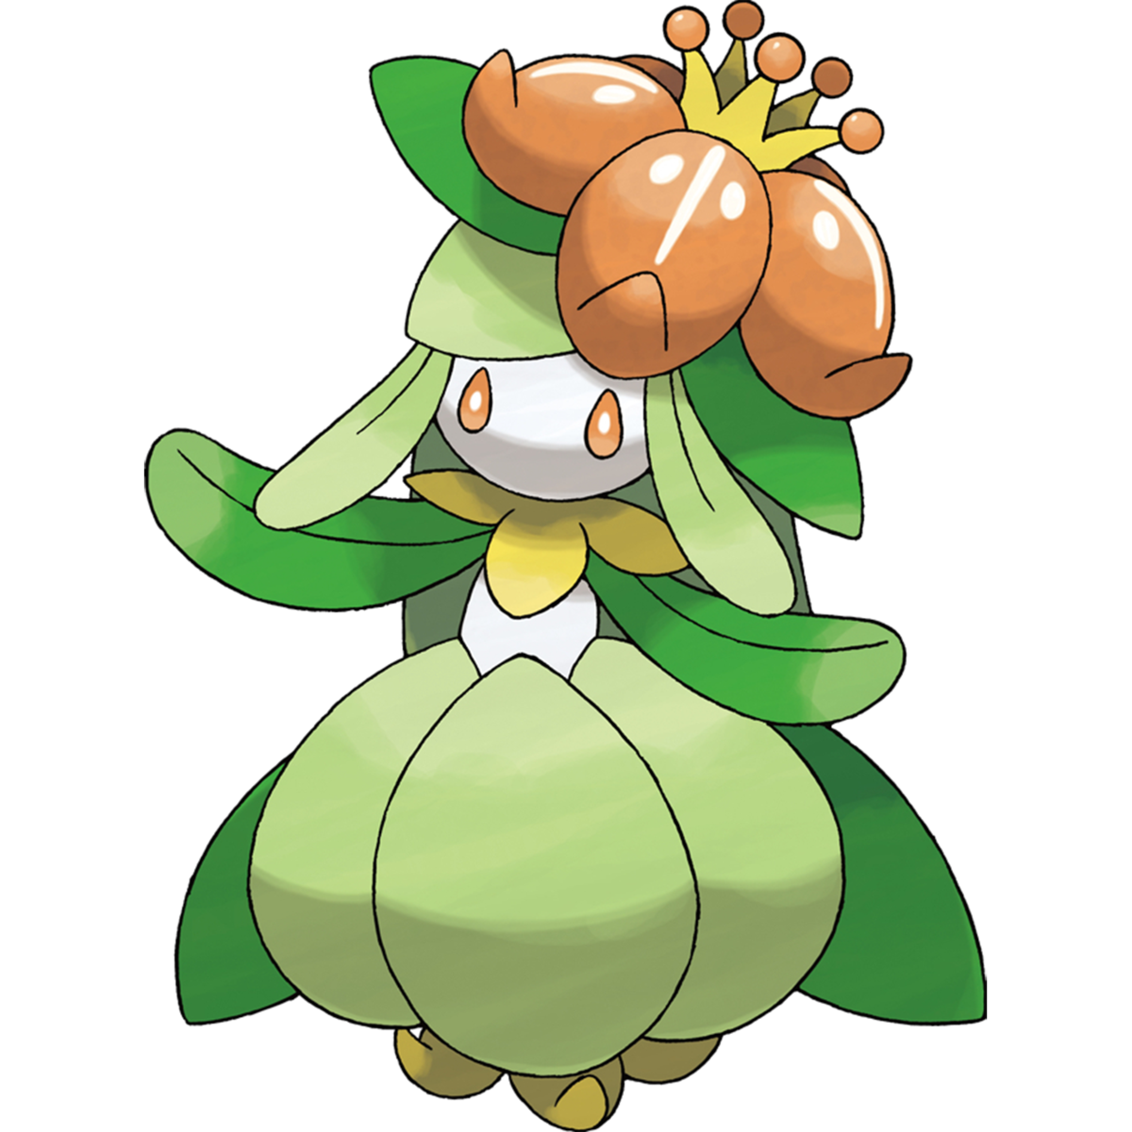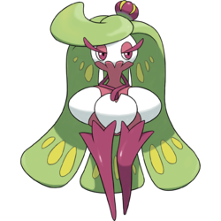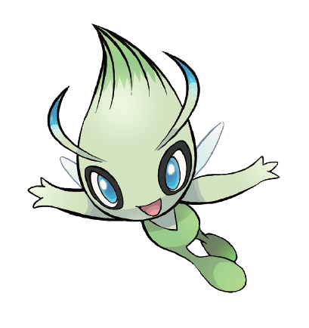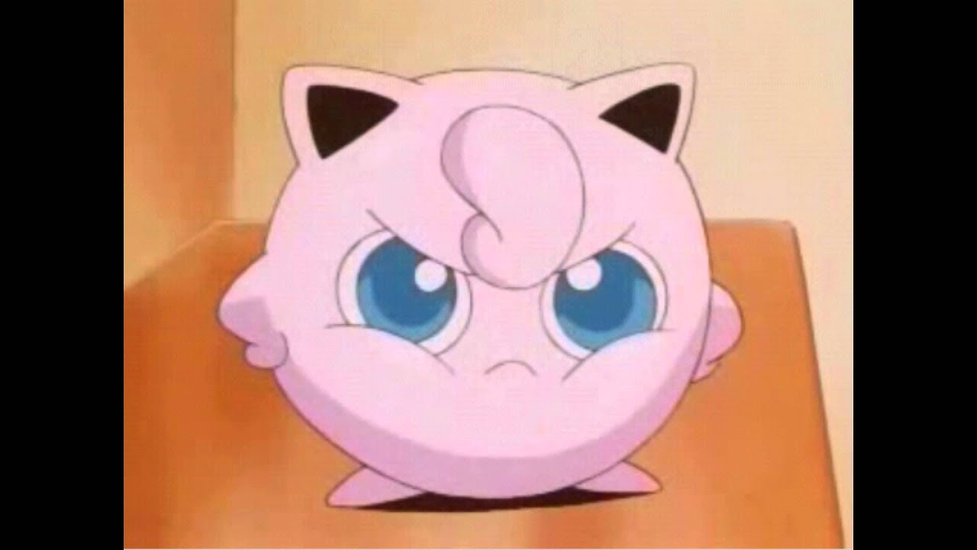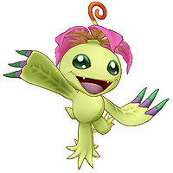
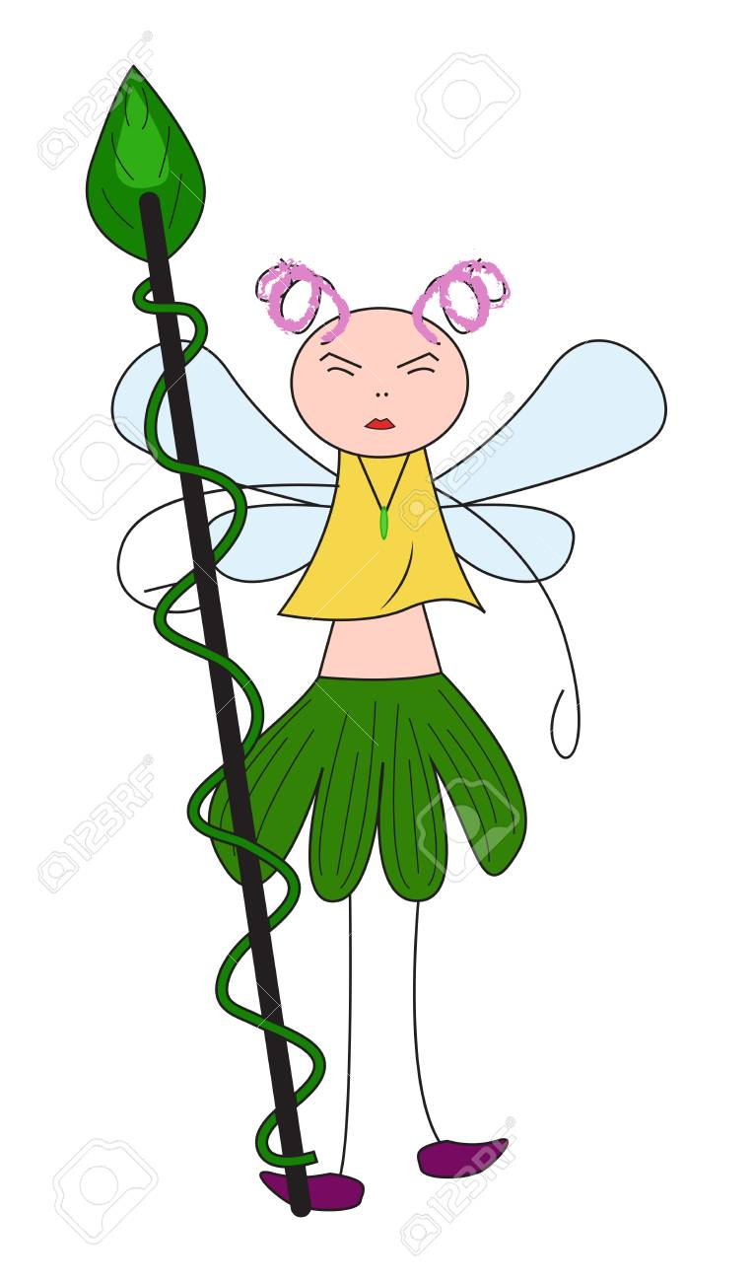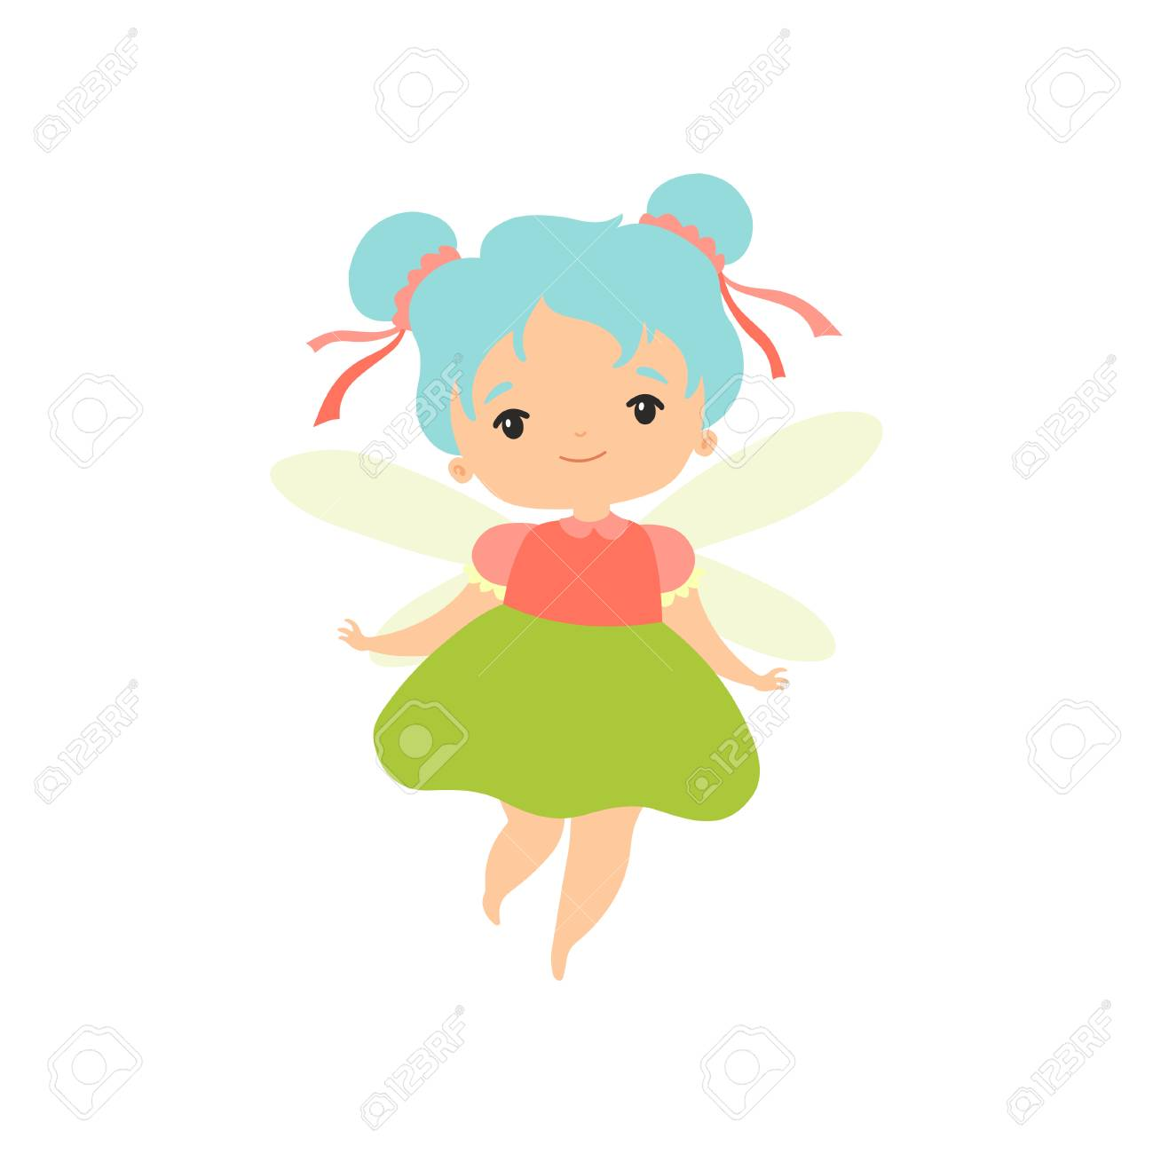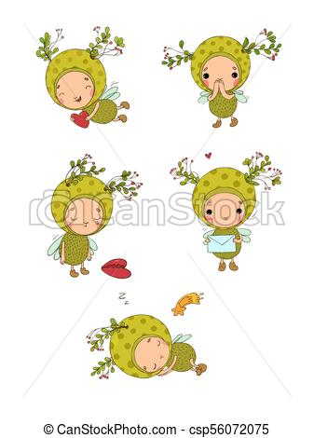

Character Questionnaire

Name of your character: Primarosie

Gender (all gender identities are welcome and acceptable): Female

Age: She’s very old because she is a forest spirit, but she acts like a sassy, curious child

Describe the way your character looks. What features make your character unique or stand out?
- Small/petite
- Large eyes and round body shapes
- Combines nature elements like flowers, branches, and bugs
- Forest spirit, so she’s small enough for people to not see her among the flowers

Describe your character’s clothing/costume (textures, style, color, etc.). What features make your character unique or stand out?
- Large flower on top of head—soft and floral
- Ladybug body/wings as the “dress”—smooth shell
- Magic staff made out of a branch—smooth bark

How would you describe your character’s personality? What emotion does your character feel the most?
- Mischievous
- Curious
- Hot-headed
- Sensitive
- Adventurous
- Graceful—particular about proper manners
- Protective

How does your character’s personality affect the way he/she/they/it moves? Use adjectives to describe your character’s poses. Or draw small doodles of the way you picture your character moving.
- She moves fast, like a buzzing fruitfly
- Hardly makes a sound and weighs very little, floats, weightless like a feather
- Very dainty and lady-like/girly when she moves
- When she gets hot-headed and uses her staff to hit people, her body gets a lot of momentum
Does your character have any special powers or abilities? If so, describe what they are.
- She has a magic staff, which helps her heal, light the way, or defend herself

Does your character have a backstory? If so, explain.

Primarosie doesn’t really have a detailed backstory. She represents the youthful, curious spirit children have when they wander through nature. She is very protective of little kids, plants, and prey animals. She is older and smarter than she looks, but her greatest characteristic is her youthful innocence and naïve, child-like appreciation for wonder in nature.

What movie, comic, TV show, video game, or business franchise universe would your character most likely be part of?

Stylistically, she is similar to series like Power Puff Girls, Secret
of Kells, and Pokémon. In terms of story universe, she would most likely be in Secret of Kells or Princess Mononoke because she is a forest spirit.

Thumbnail Sketches Part 1:

Draw a “rigged” silhouette of your character. Essentially, it’s a straight pose with raised arms that animators create as a prototype.
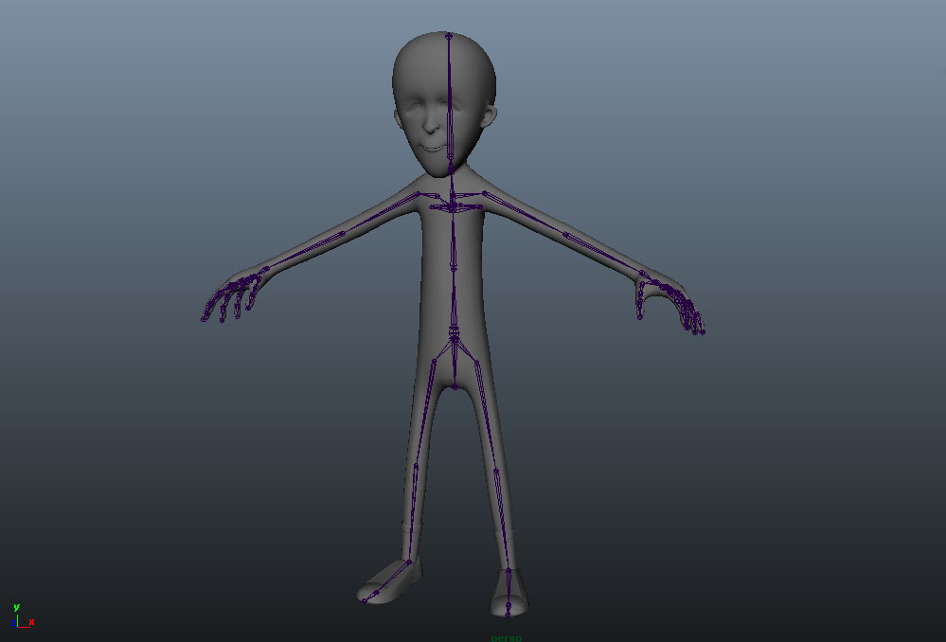

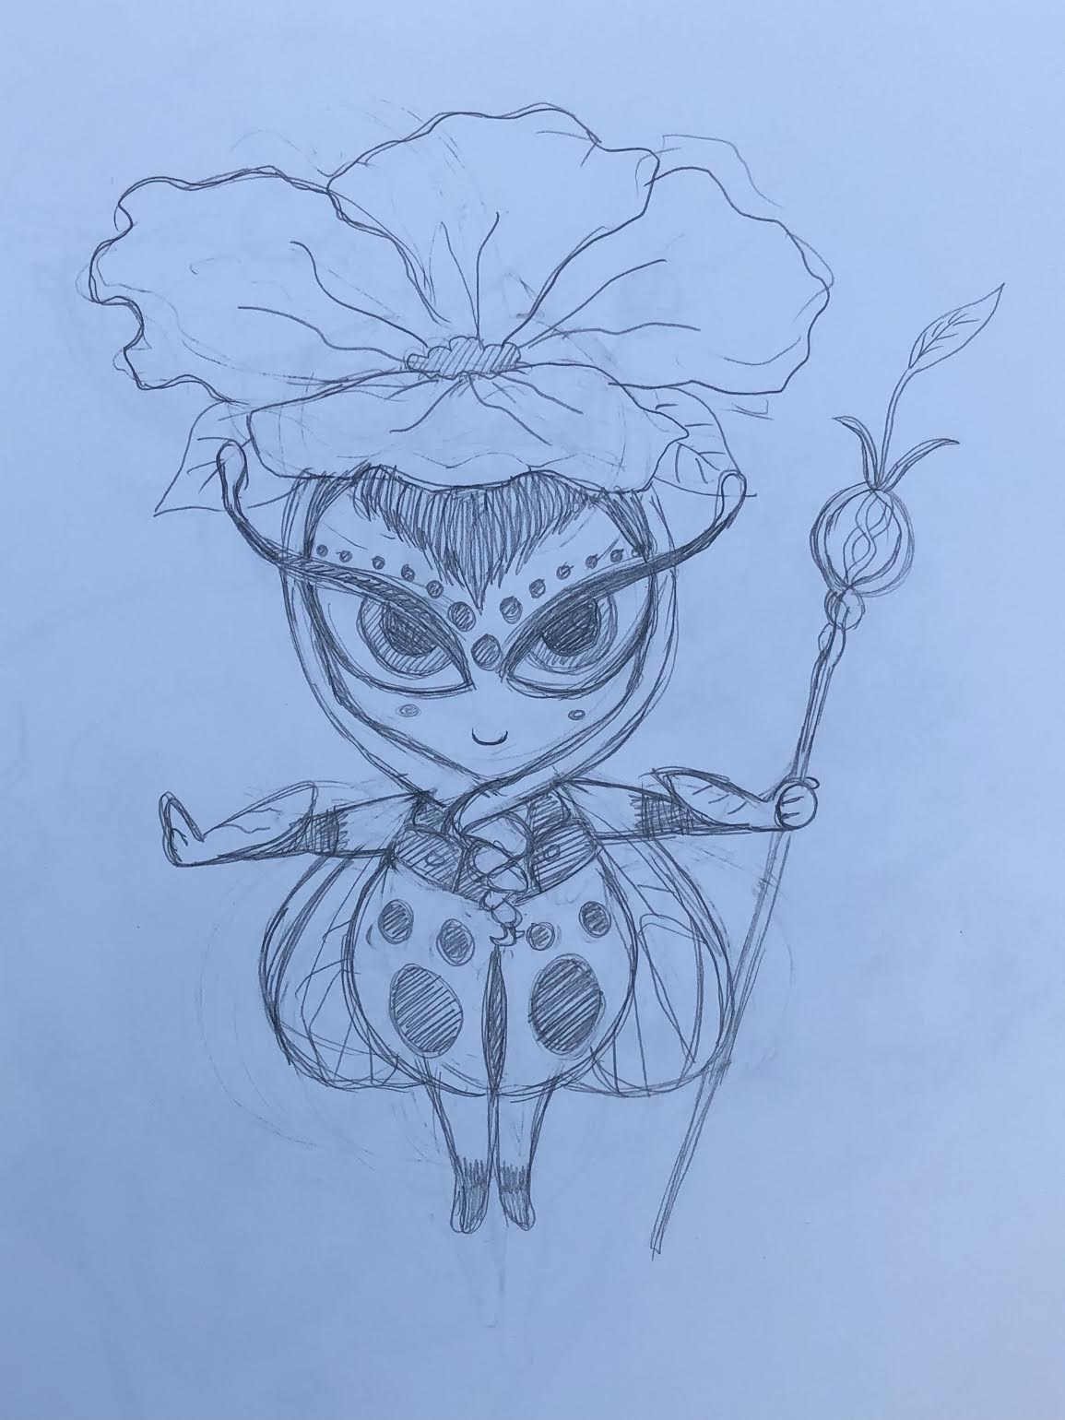

Thumbnail Sketches Part 2:

If you chose the realistic character approach, make seven gesture/action poses your character would make, with three of them being more detailed sketches. Circle the one that you would like to use for your final project.

If you chose the cartoony character approach, make seven gesture/action poses your character would make. Circle five of your favorite poses that you would like to use for your final project. Star the one that is your favorite pose.

Note: Do not worry about drawing specific character details for this part. Just focus on the gesture. Really think about planning positive and negative space in your poses.

