Lesson 2: Advanced Linear Perspective Project Artistic Research

Name:_________________
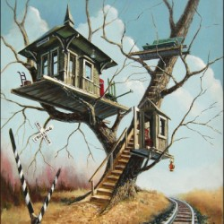

What theme does your treehouse have? What time period does it take place in? Who is allowed to go into the tree house? Is it daytime or nighttime?

What are you going to do to your treehouse to make it look original or different from other treehouses? How are you going to make it look exciting enough for someone to go inside it?

Copy and paste reference photos that would inspire the theme and exterior structure of your treehouse.

Draw the basic design for your treehouse and what kind of tree you picture it sitting in.

