Character Design Worksheet

Name: _______________________

Circle or highlight the options you’re choosing for your project:

Materials | Technical Presentation | Conceptual Presentation
Option 1: Graphite or pen/ink shading on drawing paper  Option 2: a light wash of acrylic paint with pen/ink or graphite on illustration board | Option 1: Create one realistic character.  *Note: a background is optional, but highly recommended if you plan to include this piece for your AP Studio portfolio. If you choose this option and still want to have a background, I will only give you feedback on the character design and critique your background for AP Studio.  Option 2: Create a simplified, cartoonish character with at least six different gesture drawings on a blank background. | Option 1: Create a mythical creature that relates to a natural or manmade element (wind, water, fire, earth, thunder/electricity, steel, etc.)  Option 2: Create a superhero or video game character (arcade fighting, JRPG, etc.) with special abilities, costumes, and weapons  Option 3: Create a character that represents the mascot of a business (such as a skater or energy drink company) or sports team (must be an original design)  Option 4: Create a proposal for your own character design approach (must get approved by Ms. N)

Artistic Research

Insert at least 3-4 images that reference the drawing style and poses that inspire your character. This could be from cartoons, anime, comics, movies, posters, ads, etc.

Character Questionnaire

Name of your character:

Gender (all gender identities are welcome and acceptable):

Age:

Describe your character’s physical appearance. What features make your character unique or stand out?

Describe your character’s clothing/costume (textures, style, color, etc.). What features make your character unique or stand out?

How would you describe your character’s personality?

How does your character’s personality affect the way he/she/they/it moves? Use adjectives to describe your character’s poses. Or draw small doodles of the way you picture your character moving.

Does your character have any special powers or abilities? If so, describe what they are.

Does your character have a backstory? If so, explain.

What movie, comic, TV show, video game, or business franchise universe would your character most likely be part of?

Thumbnail Sketches Part 1:

Draw a “rigged” silhouette of your character. Essentially, it’s a straight pose with raised arms that animators create as a prototype.
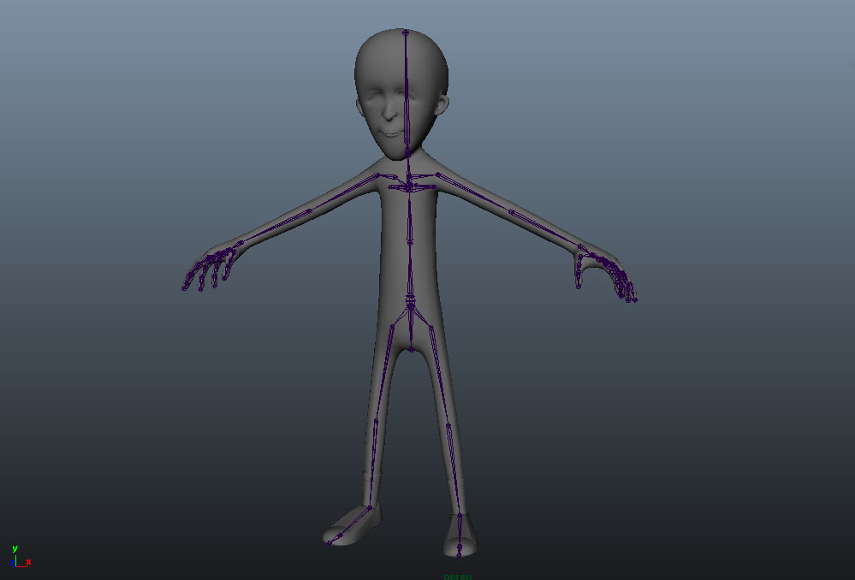

Thumbnail Sketches Part 2:

If you chose the realistic character approach, make seven gesture/action poses your character would make, with three of them being more detailed sketches. Circle the one that you would like to use for your final project.

If you chose the cartoony character approach, make seven gesture/action poses your character would make. Circle five of your favorite poses that you would like to use for your final project. Star the one that is your favorite pose.

Note: Do not worry about drawing specific character details for this part. Just focus on the gesture. Really think about planning positive and negative space in your poses.

Tips if you are stuck:
- Act out the pose in your head and have someone take pictures of it. Pretend you are your character.
- Sometimes, it helps to fill out the worksheet before drawing. Sometimes, it helps to draw before filling out the worksheet. Either way is fine, as long as every question on the sheet is answered.
- Think about your character’s cultural background. Is there a dance/sport that relates to your character’s background? That can help you with your pose.
- What kind of facial expression/body language would your character have if he/she/they/it were angry, sad, happy, or scared? This can help you come up with ideas for gestures.

