Name: Ms. Niederman
Lesson 3: Landscape Painting Based on Famous Artists
Disclaimer: Do not copy my answers if you plan to choose Georgia O’Keeffe and/or Pablo Picasso for your project. Say everything in your own words. You will lose points if I see that you copied my answers.
Artist 1

Name of artist | Art movement that this artist was part of | Materials this artist worked with | Concepts this artist liked to work with
Georgia O’Keeffe | American Modernism | Oil paint and canvas | She mainly focuses on nature and landscapes with lots of bright, rich colors. Her floral work has expressions associated with femininity.

What adjectives would you use to describe this artist’s work? | What kind of landscapes/cityscapes does this artist prefer to draw/paint? | How does the artist use color? How does he/she manipulate paint on the canvas?
Cityscapes: bold geometric shapes, pops of color, graphic novel-like, art-deco like, mysterious, foreboding, more black and earth tones compared to her floral work, noir feel. | Cityscapes: she likes to focus on tall buildings with flat or reduced details. She aims for scale and atmosphere to go for an avante-garde appearance.  Landscapes: capturing the lively essence of desert terrain, specifically in New Mexico. Color is a bigger focus to add to the personality of the place and the emotional mood she felt being there. | Paint is flatly applied and blended, but the colors are very bold with a lot of contrast. Even in her cityscape work, which has less color compared to her landscapes and flowers, still has moments of very bright, bold color.
Three images of Artist 1’s landscape/cityscape work:

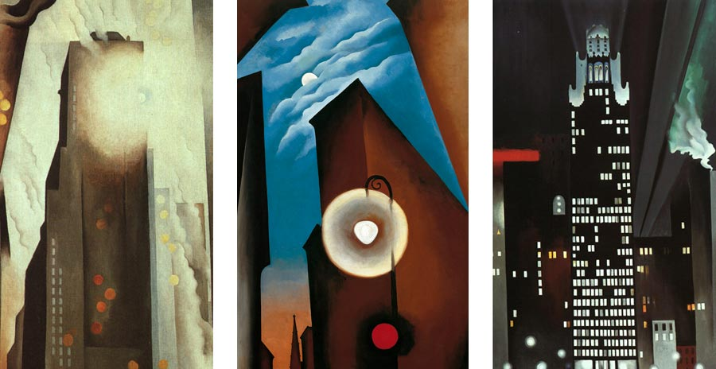

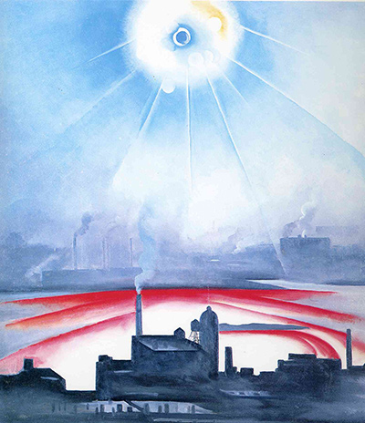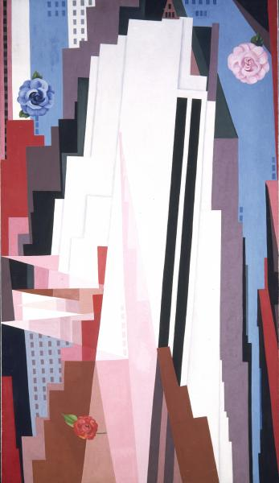

Artist 2

Name of artist | Art movement that this artist was part of | Materials this artist worked with | Concepts this artist liked to work with
Pablo Picasso | Cubism | Oil paint, sometimes charcoal | Social justice, emotional struggles with the human condition, some observational work of animals, people, and landscapes in his own style.

What adjectives would you use to describe this artist’s work? | What kind of landscapes/cityscapes does this artist prefer to draw/paint? | How does the artist use color? How does he/she manipulate paint on the canvas?
Blocky, abstract, multiple angles, confusing, disorienting, quirky, optical illusion, lively, challenging to look at. | This artist mostly works with people in his art. When he does cityscapes, he distorts the angles. Most of his buildings are square and triangular. It’s almost as if he wants the viewer to look at all the angles of the building at once. | Sometimes, he uses very bright colors. Sometimes, he uses muted, earthy colors. I think it depends on what kind of mood he wants to convey with the environment. There’s a strong emphasis on angles. Sometimes, the colors in separate angles are blended together. There’s a lot of blending, but there are a few moments when it looks like paint came straight out of the tube.
Three images of Artist 2’s landscape/cityscape work:

