AP Art Studio Syllabus

Course Objective:
The AP Art and Design course framework presents an inquiry-based approach to learning about and making art and design. Students are expected to conduct an in-depth, sustained investigation of materials, processes, and ideas. The framework focuses on concepts and skills emphasized within college art and design foundations courses with the same intent: to help students become inquisitive, thoughtful artists and designers able to articulate information about their work. AP Art and Design students develop and apply skills of inquiry and investigation, practice, experimentation, revision, communication, and reflection.
Learning Outcomes:
- Conduct a sustained investigation through practice, experimentation, and revision
- Skillfully synthesizing materials, processes, and ideas
- Articulate, in writing, information about one’s work

In this course, you will be compiling 24 works of art into a portfolio to submit to the AP review board. Twelve of those pieces will be Breadth work. The other twelve will be part of a Concentration. All of your artwork will be photograph and digitally submitted on the AP website. In addition, you will be submitting 5 physical drawings or paintings in a portfolio, which should not be any bigger than 18”x24”. This is the Quality section of your portfolio, and it should include your best pieces from both your breadth work and your concentration.

What’s the Difference Between Breadth and Concentration?
Breadth Work | Concentration
- Explores a broad range of concepts, compositions, and materials. They do not necessarily have to relate to your concentration. Risk-taking, originality, and self-expression score high.  - Technical and conceptual diversity.  - Can include work from previous classes, though there should also be new work made this year.  - Three-dimensional work does not typically go into a drawing/2-D breadth section | - Twelve drawings and paintings made this year that focus on a specific technical or conceptual theme that unifies all the pieces.  - Within the twelve pieces, there should be a technical and conceptual growth/evolution that shows your original voice as an artist and shows off your best technical skills.  - They do not all have to have the same materials, though this depends on your theme and your technical strengths.  - Choice between Drawing and 2-D portfolios

What is the Difference Between a Drawing and a 2-D Portfolio?

Drawing | 2-D
- Focuses heavily on mark-making, line quality, and surface manipulation  - Evolution in concept and materials  - The more original and authentic it is to your artistic voice, the higher your score will be  - Examples: elephants, cupcakes, feelings, gesture, portraits, still-lives  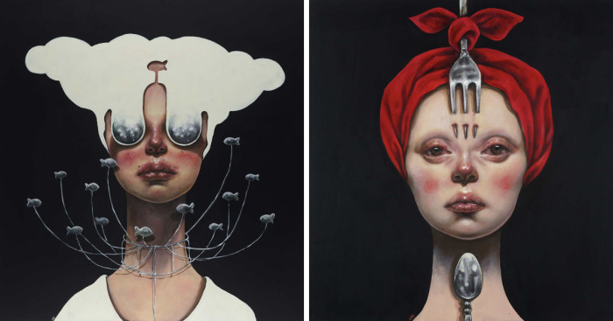  Afarin Sajedi | - Heavier focus on the application of the design elements and principles  - Examples: abstract work that focuses heavily on geometry, marketing and advertising, concept art (design stages), poster designs, stickers  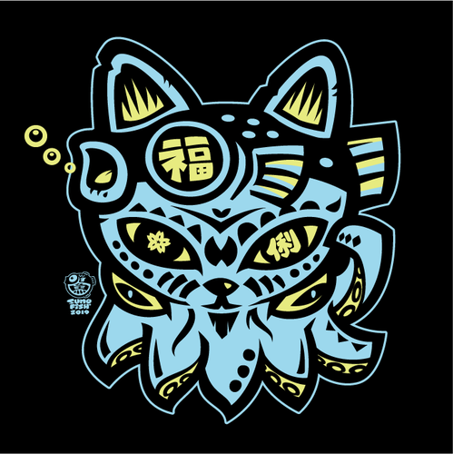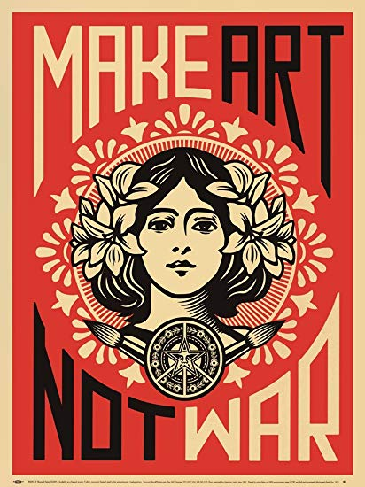  Sumofish Designs and Shepard Fairey

Suggestions for Making a Strong Breadth Portfolio:
- Plan for really, really strong compositions
- Revisit old work and think about how you could improve it
- Look for inspiration in the most unlikely places (talk to your classmates and see their work)
- Always, always, always draw in your sketchbook. Explore new concepts and experiment with new materials until you’re confident using them. Sometimes, really strong sketches can make it into your breadth portfolio (but don’t depend on it).
- Make sure that you’re showing a mastery of skills while also showing your artistic range. Don’t get stuck in your comfort zone.

Suggestions for Making a Strong Concentration:
- Pick a topic that is personally meaningful and expresses your artistic identity, but don’t forget to narrow the scope. That way, your subject is clear but you also have room to expand on the topic. Versatility is super important!
  - Example: elephants (classmate wanted to work at the zoo and loved elephants). She wanted to capture the personality and emotional expression of a specific elephant she volunteered with at the Denver Zoo.
  - Example: cupcakes (classmate wanted to do something whimsical and humorous). She started doing Wayne Theibaud cupcake studies, but it turned into a cupcake into a submarine being eaten by an octopus, cupcake sumo wrestlers, and the David eating a cupcake with the wrapper covering his crotch.
- Focus on a technical skill you excel in, but also make sure there’s more than one medium involved in the work. There should be stylistic continuity.
  - Example: elephant concentration used charcoal, oil paint, watercolor, collage made from starburst wrappers, and 2-D pottery relief
  - Example: cupcake concentration used strictly oil paint so there was stylistic continuity.
- Have fully resolved compositions. Do not turn in work with blank backgrounds. This is especially important if you are doing a concentration involving figures or animals. You will lose points on portfolios if you turn in blank backgrounds. Also, make sure you take the time to create a fully resolved background.
- Make sure the scale of your pieces is reasonable with your work ethic. If you are a slow and meticulous artist, then it might be a good idea for you to work on a smaller scale. If you have the ability to work fast while still being technically strong, then work on larger projects. Your quality work should not be bigger than 18”x24” with framing (meaning you probably can’t work bigger than 16”x20). However, you can work as large as you want for your breadth and concentration work since it will be photographed.
- “Work in threes.” This means that planning your idea in a way that it evolves. Try a certain concept within your concentration for the first three paintings. For the second three paintings, see how you can challenge yourself technically, conceptually, and compositionally. By your last painting, you need to go out with a bang.
- Plan your time wisely. Write down SMART goals, make checkpoints, and set deadlines. You should have your entire concentration done by the end of March.

Grading Breakdown

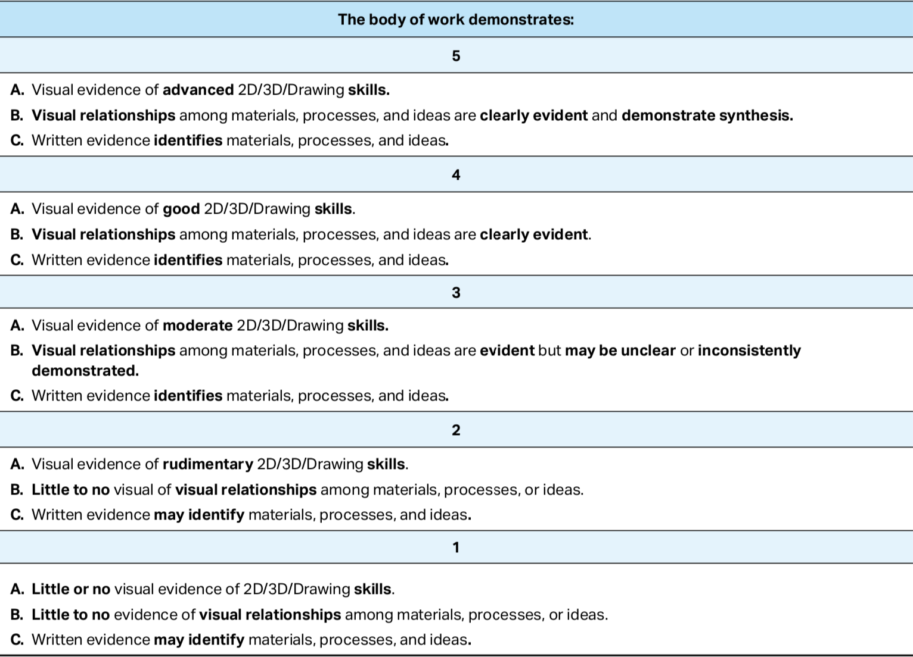
Critiques

First semester: At the end of each month, you will be photographing your work and posting one of your pieces (breadth or concentration) that you would like constructive feedback on to a website/app called Seesaw. It would be preferable that the piece is finished or “mostly resolved.” Please do not turn in half-finished work.

Afterward, you are required to write constructive feedback on at least three people’s projects. Depending on the number of people in class, I will choose the groups of people you’ll give feedback to and make sure that the groups rotate every two months. You are required to write feedback on what you think are the artist’s strengths and what their areas of improvement are (technical or conceptual). Please have at least two comments for strengths and two comments for areas of improvements. If you have suggestions for concentration ideas or future projects, please write those down too. This will total 60 points each month (20 points per person).

Starting second semester, you will be required to submit two of your pieces and comment on two people’s projects. Do not resubmit work that you already posted. I need to make sure that you are making progress on your work.

I will walk around and do check-ins/offer constructive feedback occasionally, but I will mostly stay out of your creative space. My goal is to have formal meetings with you once every two months to discuss your progress and help you set goals. During our meetings, I want you to show me your projects as well as your sketchbook work. Later in the semester, we’ll workshop artist’s statements.

Critique Deadlines:

- September 28
- October 30
- November 22
- December 13
- January 31
- February 28
- March 27
- ALL TWENTY-FOUR PIECES SHOULD BE PHOTOGRAPHED AND TURNED IN TO THE AP REVIEW BOARD BY APRIL 30

Seesaw website: https://web.seesaw.me

Grading

Even though the AP board will give you your final score on your entire portfolio, I will still grade you on these important things:
- Studio Participation and Clean-Up: your work ethic is focused and you’re not spending all your time lollygagging on your phone or distracting others. Use your social time to get constructive feedback from peers on your work or ask them questions about their concepts/process. I will also tally how many projects you’ll have done each month in my gradebook.
- Participation in Critiques: critiques are super important for artists to learn what their strengths are, as well as how they can improve. Critiques can also give you ideas for your own work when you feel stuck. Please participate and support your classmates.
- Initial Research and Worksheets for Planning Your Concentration: this will be done during the first week of school.

All rubrics will be posted on my teaching website.

Go onto my teaching website for important information and resources: https://niedermanartclass.weebly.com. You can access the URL on my A-West teacher profile.

Finally…

Mr. Oelschlager and I are staying in close contact during his sabbatical year. He took the year off to focus on his professional art career. We agreed that it would be fun for him to post his paintings and his exhibition opportunities onto Seesaw so all of you can get a taste of what it’s like to be a professional fine artist. Essentially, Mr. O. is making a concentration of his own, and his work will evolve just like yours will during the year. We are planning to have him speak to the AP class sometime in the spring (possibly April) so he could share what his experience was like. Since he will also see what images you’ll post for critique, he may offer his feedback as well.

